

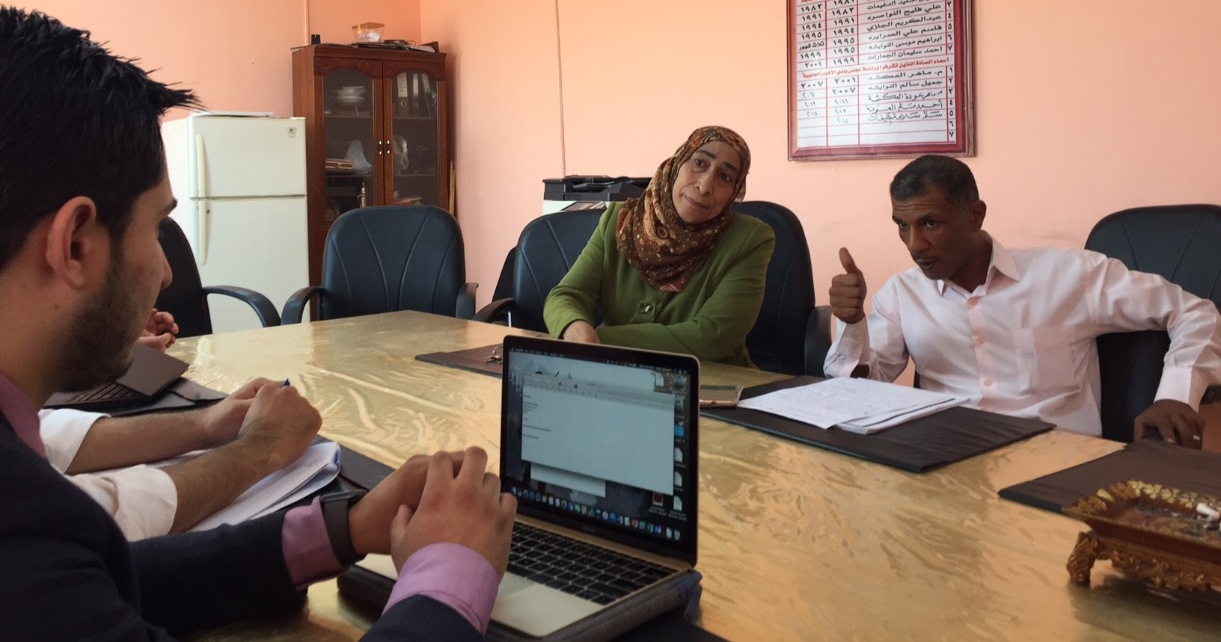
December 2017
This publication was produced at the request of the United States Agency for International Development. It was prepared by Dan Killian, Jacob Patterson-Stein, and Dima Toukan of Management Systems International, a Tetra Tech company.

Evaluation Design report
cities implementing transparent, innovative, and effective solutions (cities)

CITIES Evaluation Design report

Submitted September 2017
Revised December 2017
USAID/Jordan Monitoring and Evaluation Support Project (MESP)
Contracted Under AID-278-C-13-00009

Cover Photo: Municipal officials express their hopes and concerns regarding implementation of the Kingdom’s new decentralization agenda.
Photo Credit: Jacob Patterson-Stein



Management Systems International
Corporate Offices
200 12th Street, South
Arlington, VA 22202 USA

DISCLAIMER
The authors’ views expressed in this publication do not necessarily reflect the views of the United States Agency for International Development or the United States Government.

CONTENTS
Acronyms 5
Executive Summary 6
Introduction 7
Background 7
Cities Implementation 8
CITIES Development Hypotheses and Theory of Change 10
Other Local Governance Efforts 10
Evaluation Purpose and Scope 10
Evaluation Methodology 11
Evaluation Questions 12
Evaluation Theory of Change and Hypotheses 12
Evaluation designs for causal inference 14
Evaluation indicators 19
Learning Agenda 22
Relationship between the Learning Agenda and Impact Evaluation 25
Gender and Social inclusion in Evaluation 26
Data collection 27
Implementation Fidelity 31
Analysis 32
Matching municipalities 32
Sample sizes and statistical power 39
Qualitative Data Analysis 44
Strengths and Limitations 44
Data Management Plan 46
Conclusion 47
Annexes 51
Annex 1: Selected bibliography 51
Annex 2: Select Activities Aligned with CITIES Goals 52
Annex 3: Evaluation Hypotheses Mapped to Illustrative Survey Questions 56
Annex 4: Analyzing Institutional Capacity 58
Annex 5: Listing of Selected Treatment and Comparison Municipalities 60

TABLES
Table 1 CITIES evaluation questions 12
Table 2 CITIES Evaluation hypotheses for measuring effectiveness 14
Table 3 Evaluation indicators 20
Table 4 Primary learning agenda questions 23
Table 5 Data collection methods and indicators 27
Table 6 Initial balance across treatment and comparison, Class B-D municipalities 34
Table 7 Standardized differences across municipality characteristics 38
Table 8 Indicators from CEP survey 41
Table 9 CITIES evaluation team 47
Table 10: MICA Items Under Municipal Control 59

FIGURES
Figure 1 Local government structure 8
Figure 2 Jordan's Governance Structure and CITIES activities 9
Figure 3: Simplified CITIES Theory of Change Diagram 10
Figure 4: Evaluation Theory of Change 13
Figure 5 Difference-in-differences (d-i-d) evaluation design 15
Figure 6 Difference-in-differences with spillover group 17
Figure 7: Distribution of propensity scores across treatment and comparison groups 36
Figure 8 Standardized differences across selected treatment and comparison municipalities 37
Figure 9 General sampling design for the population survey 40
Figure 10 Distribution of CITIES sample sizes from population survey, from 10,000 simulated draws 42
Figure 11 Simulated power curves based on CEP data 43
Figure 12 Population survey implementation schedule 49

Acronyms
ADS | Automated Directives System
CEP | Community Engagement Project
CITIES | Cities Implementing Transparent, Innovative, and Effective Solutions
DEC | Development Experience Clearinghouse
d-i-d | Difference in differences
FY | Fiscal Year
GoJ | Government of Jordan
IE | Impact evaluation
MEL | Monitoring, Evaluation, Learning
MoI | Ministry of Interior
MoMA | Ministry of Municipal Affairs
MoPIC | Ministry of Planning and International Cooperation
PSM | Propensity Score Matching
SOW | Statement of Work
USAID | U.S. Agency for International Development

Executive Summary
USAID/Jordan has requested technical support from its institutional contractor, the Monitoring and Evaluation Support Project (MESP), in designing a prospective evaluation and learning agenda of its municipal governance initiative, Cities Implementing Transparent, Innovative, and Effective Solutions (CITIES). By strengthening municipal institutional capacity, improving public service delivery, and strengthening community resilience and cohesion, it is expected that citizens will ultimately judge their local municipality to be more responsive to their needs and more effective in executing their core functions.

This Design Report establishes the rationale, design, and operational activities for such an evaluation. The evaluation uses a mixed methods approach to compare institutional-level measures between 15 treatment and 15 comparison municipalities, small-scale surveys of direct beneficiaries of municipal service improvements, and qualitative inquiry to understand the context-specific factors behind municipal institutional capacity development and successful implementation of a decentralization agenda. The evaluation also includes a learning agenda to help understand the environment in which findings are situated, identify heterogeneous treatment effects, and learn which factors strengthen or impede activity success. To the extent feasible, all data will be disaggregated by youth, gender, and membership in a marginalized group, and these disaggregations will also be examined as a cross-cutting theme across the primary fields of inquiry around institutional development and improved service delivery.

For much of its history, USAID has relied upon local governance and community development programming as a primary tool to foster democratic norms and institutions. Complementary to this effort has been longstanding support of and advocacy at the central level for political and fiscal decentralization. While community development and political and administrative decentralization has a long history amidst a general consensus that such programming is effective at delivering resources to the local level while building democratic capacity through participatory planning and budgeting processes, only recently has a body of evidence started to coalesce around the specific outcomes of such programming and their magnitudes.

This evaluation will contribute to the emerging body of evidence in order to help USAID better tailor subsequent democracy and governance investments in Jordan and elsewhere. The findings from this evaluation and the learning agenda will help USAID, the Government of Jordan, and the broader donor and governance community better understand the impact of decentralization efforts at the municipal institution level and for the citizens who ultimately benefit from efforts to make government more effective, equitable, and responsive.

Introduction
This document provides a framework for an impact evaluation (IE) design and identifies illustrative questions for an exploratory learning agenda. First, it describes the Jordanian governance context and the main CITIES activity components, which have been designed to address key decentralization and local governance efforts specific to Jordan. The document then lays out the evaluation questions, theory of change, analytical approach, and key indicators for the learning agenda. The data collection approach and implementation fidelity monitoring are somewhat novel in this design as they combine household survey, implementing partner data, and qualitative measures to develop an overall estimate of the activity’s impact. Subsequent sections focus on the analytical approach for matching pre-chosen CITIES municipalities with a group of comparison municipalities and the sampling plan, followed by a discussion of the data analysis methods for qualitative data. The final sections cover the data management plan, the proposed evaluation team composition, and the evaluation’s baseline timeline.

Since the proposed IE design requires that endline data be collected after the current end date for the MESP contract (November 2018), the design and estimated timeline for data collection, analysis, and reporting activities are presented for baseline only. Additional coordination between MESP and USAID will be needed to determine how to proceed with evaluation activities that extend beyond the current MESP mechanism.

Background
Strengthened democratic accountability is critical to Jordan’s stability and future prosperity. Over the past 10 years, Jordan has pursued several structural reforms to enhance the conditions for liberalization and more inclusive growth. Decentralization is an integral part of the reform agenda, undertaken to encourage a greater proportion of citizens to engage politically and to mitigate the stressors that are affecting them on a daily basis. Adverse regional developments, in particular the Syria and Iraq crises, continue to affect Jordan in the form of increased socio-economic pressures due to the vast inflow of refugees.

There is a long tradition of official municipal organization in Jordan, yet developing relevant, responsive, and representative local institutions remains an ongoing challenge. Municipalities as a modern governance institution were developed in 1955 and have been subject to several reform efforts (Ababsa 2003). In 2002, the Ministry of Municipal Affairs (MoMA) consolidated the number of municipalities across the Kingdom to address financial insolvency issues, with the total number of municipalities falling from 328 to 99. There are now 100 municipalities, which receive funding from the national government based on their population, and within which there is a municipal council voted into office through local elections. Municipalities collectively cover an estimated 83 percent of Jordan’s population. This local administrative structure overlaps with other institutions that exist at the sub-national-level, such as governorates, and Ministry offices and initiatives, such as Local Development Units, which are responsible for socioeconomic development in municipalities and governorates.

In 2015, Jordan passed both a Decentralization Law and a Municipalities Law as part of an effort to integrate municipalities into a general governance framework and increase accountability among local democratic institutions. Amman has been the locus of control and remains the primary service provider across Jordan. Recent local elections that took place in August 2017 under the new legal framework provide a window of opportunity to strengthen local governance and engage communities in their own development. The elections brought elected local councils, mayors, municipal councils and governorate councils under a new system of governance that is expected to strengthen accountability and transparency, improve service delivery and increase community engagement. It remains to be seen if these recent legislative measures, and the increased enfranchisement at the municipal level lead to improved local governance and increased citizen engagement.

Figure 1 Local government structure
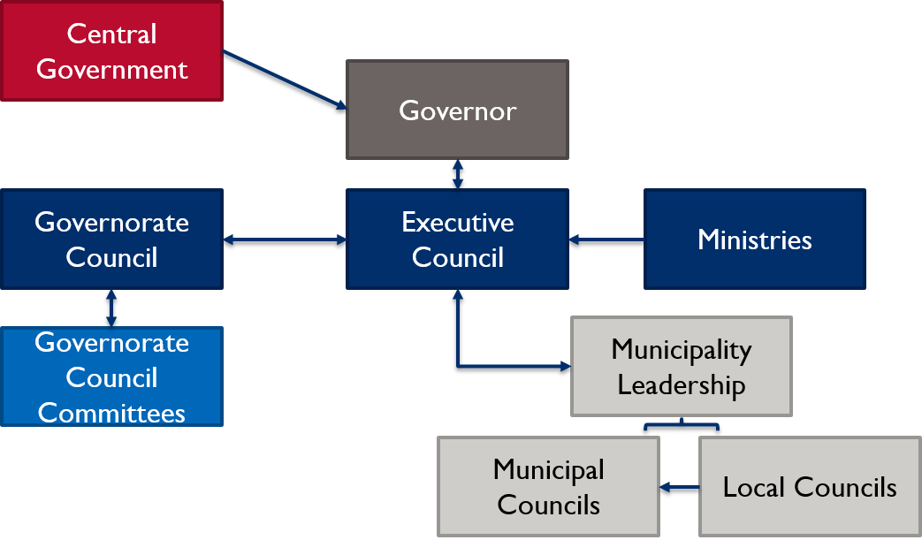

Cities Implementation
USAID commissioned Cities Implementing Transparent, Innovative, and Effective Solutions (CITIES), a five-year activity that Chemonics International started implementing in October 2016, to further assist the Government of Jordan (GoJ) in its efforts to improve local service delivery and governance, citizen engagement, and accountability at the municipality level. CITIES will be implemented in 33 municipalities across all 12 governorates in Jordan.

CITIES implementation is based around four components that cut across its overarching decentralization facilitation goal:
- Improved Service Delivery: Illustrative activities include the Development of Service Delivery Improvement Plans (SDIP); assistance with solid waste management (SWM); conducting municipal institutional capacity assessments (MICA); and additional activities that align with MOMA priorities.
- Increased Effectiveness of Local Government Operations: Illustrative activities include analysis on legal and regulatory frameworks; review of human resources, financial, organizational, and budgetary management in municipalities.
- Increased Responsiveness to Community Priorities: Illustrative activities include support for the Ministry of Political and Parliamentary Affairs; and assessment of public outreach tools.
- Enhanced Capacity to Promote Community Cohesion and Resilience: Illustrative activities include youth engagement, grant support and local development capacity building.

By strengthening municipal institutional capacity, improving public service delivery, and strengthening community resilience and cohesion, it is expected that citizens will ultimately judge their local municipality to be more responsive to their needs and more effective in executing their core functions. As shown in the figure below, most of CITIES activities are focused at the municipality level of government, but implementation for component 2 activities does include interventions at higher-levels, as well. The results of CITIES are expected to contribute to USAID’s development objective of stronger democratic accountability and a more stable, prosperous Jordan.

Figure 2 Jordan's Governance Structure and CITIES activities
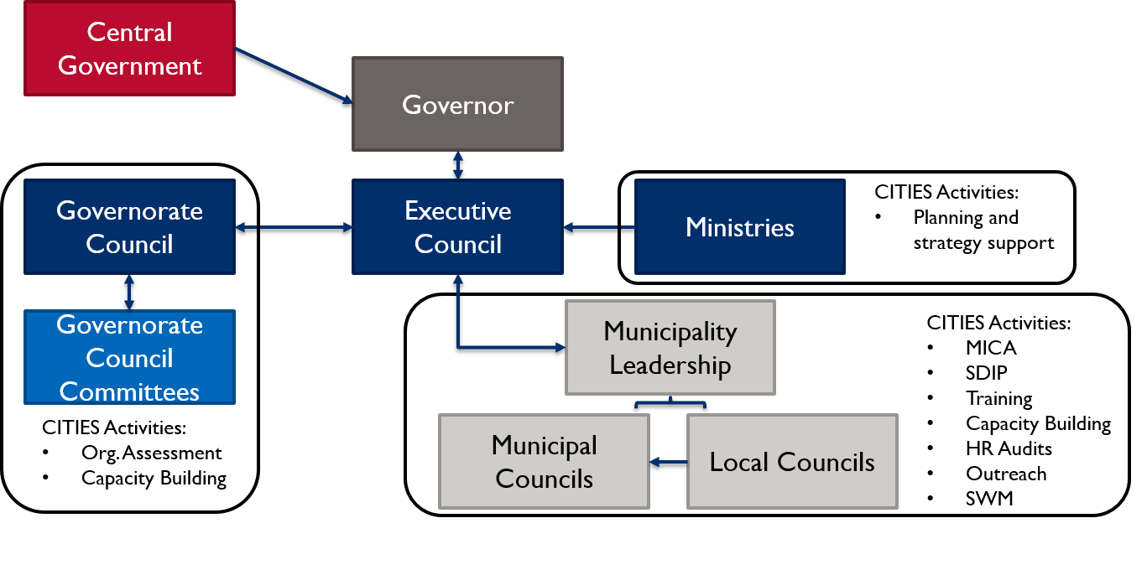

CITIES Development Hypotheses and Theory of Change
According to the CITIES Monitoring, Evaluation, and Learning (MEL) plan, if municipal government effectiveness and service delivery is increased, and if municipalities are better able to address the priorities of their community members while promoting community resilience, then democratic governance will be enhanced; trust and confidence in elected officials will be improved; and stability will be strengthened. A simplified theory of change (with arrows denoting the ‘how’ rather than ‘so what’ question) is as follows:
Figure 3: Simplified CITIES Theory of Change Diagram
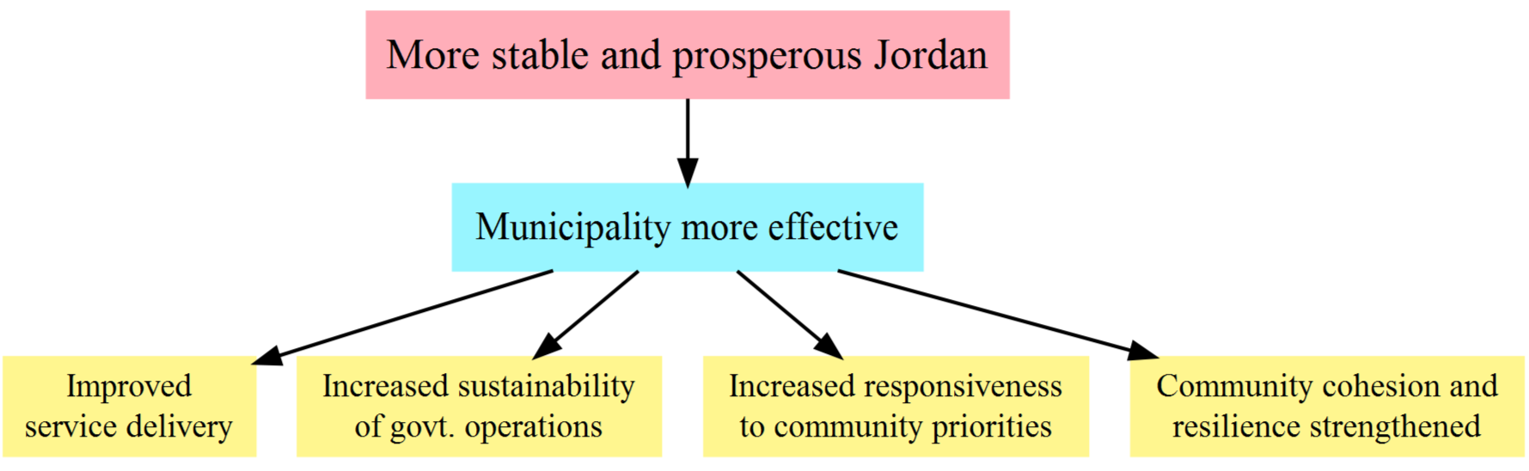

Other Local Governance Efforts
There are several USAID and other donor-funded activities that support aspects of local institutional strengthening in Jordan. Annex 2 provides a summary of each of these activities. For example, the World Bank is coordinating with USAID to strengthen municipal capacity in response to the influx of Syrian refugees, particularly in host communities. The Federation of Canadian Municipalities is implementing a five-year program to strengthen municipality resilience in the Central and Southern parts of Jordan. The German development agency, Deutsche Gesellschaft für Internationale Zusammenarbeit (GIZ), also has three water, wastewater, and treatment activities that are similar to CITIES municipal service delivery component. In addition, USAID has programs across Jordan that support essential public services that affect life in the municipalities, such as water, education, and health interventions. USAID also supports engagement between civil society organizations (CSOs) and government institutions; promote social cohesion and build local institutional capacity in areas with large refugee populations; and enhance local governance, elected official capacity, and conduct public opinion research.

Each of these activities has their own geographic implementation areas and scopes, but support the general goal of strengthening local institutions and supporting decentralization broadly. CITIES will likely implement in areas where at least some of the residents have had the opportunity to benefit from another donor-funded activity, as well as any locally funded development efforts.

Evaluation Purpose and Scope
USAID/Jordan is commissioning this evaluation to assess CITIES progress towards achieving its objectives, and examine how the implementation of CITIES affects municipal operations, the quality of public services, public perceptions of local municipality effectiveness, relevance, and responsiveness, community cohesion, and general quality of life. This evaluation is tasked with focusing on outcomes at the municipal level as measured through the MICA score, but will also collect household-level information to assess how individuals are responding to changes in their communities. The evaluation will also consider the implications of any unanticipated positive or negative outcomes. The data collected for this evaluation will complement the data collection and reporting that Chemonics will perform on their target municipalities.

Audience and Use
USAID/Jordan is the primary audience for this evaluation. The implementing partner and GoJ are also key recipients of the findings of this evaluation. Given the broad presence of donors working on decentralization and limited rigorous evidence on decentralization, the results of this IE will be relevant for general learning on how development activities affect governance.

USAID will use this evaluation to inform the design and implementation of future democracy, human rights, and governance (DRG) activities. As one of the first rigorous evaluations of local governance in Jordan, the evaluation will serve as a tool for USAID, the implementation community, other donors, and GoJ to learn about how active engagement on civic outreach, capacity building, and municipal responsiveness affect people in their daily lives. Given that there is no certainty about what the results will show, it will be important to use the findings of this IE as a platform for dissemination and discussion on decentralization and local governance in Jordan, as well as the impact of DRG activities more broadly.

Evaluation Scope
As described further under the data collection section, this evaluation will cover 15 of the 33ITIES municipalities as well as a comparison group of municipalities to draw conclusions about the effect of CITIES. The primary focus of evaluation measures is at the institutional level, in order to test the intervention’s theory of change that capacity development will engender improved citizen engagement, municipal planning, and service delivery at its most critical juncture. Small-scale surveys will assess the extent of additional or improved services and solicit citizen perceptions proximate to improved services. Additionally, a learning agenda will ask ancillary questions to understand the implementation environment or explore specific pathways through which outcomes are realized. Finally, the evaluation will draw from a general population survey and learning agenda that MESP is undertaking separately for USAID. This activity will provide household-level data on both CITIES and non-CITIES households that will be used to test CITIES hypotheses on citizen engagement and government responsiveness and effectiveness.

Evaluation Methodology
This section reviews the general evaluation questions, specific hypotheses testing the intervention’s theory of change, the inferential design strategy to answer whether the intervention is realizing outcomes, a set of learning agenda questions to ask secondary questions about CITIES outcomes or implementation dynamics, and modes of data collection that will map to 10 indicators measuring specific hypotheses or learning agenda questions.

Evaluation Questions
The evaluation team will organize its work according to broad performance evaluation questions that examine activity effectiveness, sustainability, synergies, and learning. Impact measurement will test specific hypotheses under activity effectiveness. Qualitative / mixed methods inquiry will address broad themes of sustainability and synergy. Finally, a set of learning agenda questions will formalize what can be learned analytically through triangulation of data sources and secondary data analysis. Additional lines of inquiry may be added as the evaluation team learns more about implementation, and CITIES adapts to local municipality needs. The evaluation questions are summarized below.
Table 1 CITIES evaluation questions
Theme | Question(s) | Approach
Effectiveness | - What is the overall effectiveness of CITIES for achieving its goals of enhancing democratic governance, improving trust and confidence in elected officials, and strengthening stability?  1a. Did the activity achieve its intended outcomes?  1b. Are there certain areas/activities and components  that have been more effective than other  areas/activities and components? | Effectiveness is measured by 10 indicators across six hypotheses. See the indicator list for additional detail.
Sustainability | - Which interventions under CITIES are most likely to be sustained over time? Why and how? To what extent are CITIES capacity building efforts being sustained by municipalities and other targeted bodies of decentralization? | Qualitative inquiry, triangulation of data sources, expert observation and judgment
Synergies | - How well has CITIES developed synergies (coordination and collaboration) with other USAID activities that focus on similar objectives, for example, decentralization and working with Municipalities? Are donors operating in the decentralization and local governance space achieving synergies through coordination or knowledge sharing? | Qualitative inquiry, triangulation of data sources, expert observation and judgment
Learning | - Based on the performance of CITIES, both in terms of effectiveness and sustainability, what are some key lessons learned, by component and sub-activity? | Summary reflection across all evaluation activities and data. Learning agenda questions for specific inquiries about the mechanics of implementation and outcomes.

Evaluation Theory of Change and Hypotheses
As first stated in the CITIES evaluability assessment, it can be helpful to explore the causal pathways of a development hypothesis in more depth than is traditionally captured in USAID activity MEL plans. The evaluation team has examined CITIES implementation plans and met with key CITIES staff to understand how the various activities relate to the activity’s overarching goal. Any evaluation must have a strong understanding of the various mechanisms that contribute to the outcome of interest. The figure below follows the various programmatic streams under CITIES and relates these through seven hypotheses to key outcomes and overall goal.

Figure 4: Evaluation Theory of Change
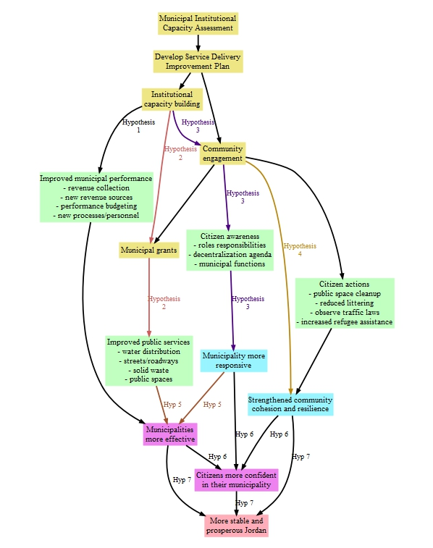
In this extended logic model, boxes in yellow represent programmatic inputs, light green boxes represent intermediate outcomes, light blue boxes represent activity outcomes, and purple boxes represent mission-level outcomes. All boxes feed into the overall USAID mission goal of a stable and prosperous Jordan. Note that the highest level impact indicator in the CITIES MEL plan is municipal government effectiveness, while the CITIES evaluation includes the higher level impact measures of confidence and stability. For accountability purposes, CITIES performance targeting applies only to its sub-purpose outcomes of service delivery, institutional capacity, responsiveness, and cohesion, and its activity level impact measure of municipal government effectiveness.

For measurement and learning purposes, the overall CITIES development hypothesis and theory of change is broken into seven constituent hypotheses based on how programmatic inputs and activity outcomes may interact to produce desired results. This also enables the evaluation team to better assess the different aspects of activity implementation and their respective contributions to observed outcomes. However, while the validity and directionality of each hypothesis will be explicitly tested, and the evaluation learning agenda will examine how the failure of one hypothesis may affect downstream hypotheses, the figure above cannot pretend to fully capture the realities of activity implementation. Rather, this extended logic model is designed to identify hypotheses that contribute to mission learning about what works and what doesn’t, but also recognizes that actual interactions from implementation will likely remain too complex to be fully diagrammed. These constituent hypotheses referenced in the figure above are presented in the table below.
Table 2 CITIES Evaluation hypotheses for measuring effectiveness
Hypothesis 1 | If CITIES provides institutional capacity building, then municipal operations will improve.
Hypothesis 2 | If CITIES provides institutional capacity building, combined with incentive grants and improved public service delivery, then this will lead to an improvement in the quality of public services.
Hypothesis 3 | If CITIES provides institutional capacity building, combined with proactive outreach by municipalities, then this will increase public perception that municipalities are responsive to citizen needs.
Hypothesis 4 | If CITIES supports increased attention to marginalized groups, such as youth, gender, nationality, and disability, then this will strengthen a sense of community cohesion and resilience.
Hypothesis 5 | If CITIES provides institutional capacity building, combined with proactive outreach and increased / improved public service delivery, then this will increase public perception that municipalities are effective.
Hypothesis 6 | More effective public service delivery, responsiveness to citizen needs, and strengthened community cohesion and resilience will increase citizen confidence in their municipality.
Hypothesis 7 | More effective public service delivery, confidence in local leadership and performance, and strengthened community cohesion and resilience will lead to a more stable and prosperous Jordan.

See below for the proposed evaluation indicators to measure each hypothesis.

Evaluation designs for causal inference
This section presents the primary inferential design features of the evaluation. The base model will employ difference-in-differences across treatment and comparison municipalities, and difference-in-differences with the addition of a spillover group within intervention municipalities. These models assume that the measured units are repeated cross-sections of a larger population; in the event that the same units are tracked over time, the evaluation team will employ more efficient models that exploit the advantages of tracking the same units over time. Learning agenda questions will be addressed by multivariate analysis and/or qualitative inquiry, but without a specific inferential design.

Difference-in-differences
The basic measurement to estimate outcomes will follow a difference-in-differences (d-i-d) approach, in which a sample of both treated and untreated units (in this case, municipalities) are examined before (baseline) and after (endline) treatment. Examining the first differences in outcomes across both groups (trends) rather than at single points in time (levels) has the important effect of removing any unobserved sources of bias in the data that are common to both groups and remain constant over time. The difference between the trend lines of each group (the second difference) then generates an estimate of the overall treatment effect. Diagrammatically, the design is as follows:
Figure 5 Difference-in-differences (d-i-d) evaluation design
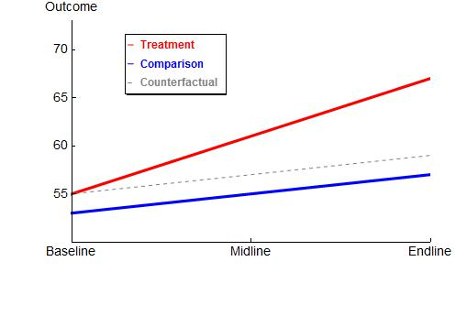
Analytically, the d-i-d model may be expressed as follows:

In this model, 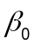 is the outcome in the comparison group at baseline, 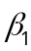 is the difference between the treatment and comparison groups at baseline, and  is the change across baseline and endline in both treatment and comparison groups that is unrelated to CITIES. The overall treatment effect of the intervention is , or the interaction of treatment and time. One may also include a set of control variables,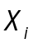, that help statistically adjust for any correlation between observable characteristics and outcomes. The final term is a theoretical construct representing all dynamics or factors that are unobserved by the analytical model. As this term is unobserved, it must be theorized by the evaluator to assess how the causal effect estimates may break down in a real world setting. If there are any dynamics or factors correlated with outcomes but not captured by first differences or the set of control variables, then this model may produce misleading or unreliable estimates. Additionally, if the treatment and comparison groups would follow different trend lines over time in the absence of treatment, then the d-i-d estimator fails to produce unbiased measures.

Difference-in-differences with spillover
In the previous model, municipalities are the basic unit of treatment and municipal level measures are compared against measures from other, untreated municipalities. This design becomes problematic when examining activity outcomes measured amongst citizens, as there would be a significant proportion of a municipal population that remain untouched by CITIES activities. The evaluator must then limit the study population to direct beneficiaries within municipalities.

However, it is of programmatic interest to identify the boundaries of CITIES effects. That is, how much service delivery or other improvement is needed before a local governance initiative begins to affect entire populations within a service delivery area? Is there a ‘contagion’ effect of improved municipal operations affecting some beneficiaries which begins to positively affect other residents within the municipality? In order to address such dynamics, the beneficiary population of a municipality is partitioned into direct beneficiaries exposed to CITIES activities, and indirect beneficiaries who live within the municipality but were not directly exposed. The population of indirect beneficiaries can be further partitioned into those who have witnessed the implementation of activities and/or heard about them through media or social networks.

Questions of indirect exposure will be addressed at the data analysis stage, but for purposes of illustration indirect beneficiaries within a treated municipality may be considered a part of a spillover group in order to investigate whether and how programmatic inputs diffuse through a beneficiary population. Diagrammatically, the d-i-d with spillover model may be expressed as follows:

Figure 6 Difference-in-differences with spillover group

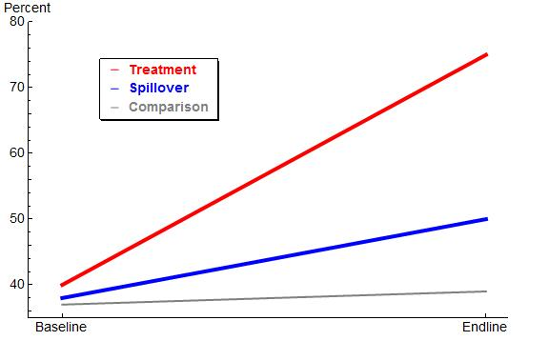

Analytically, the d-i-d with spillover model may be expressed as follows:

This model is identical to the d-i-d model, but also adds two terms. The term 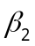 represents differences at baseline between citizens in comparison municipalities and citizens in treated municipalities who are not direct beneficiaries of CITIES activities. The term 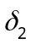 represents the spillover effect, if any, of CITIES activities on municipal residents. Citizens subject to spillover effects may not be direct beneficiaries of CITIES activities, but may nevertheless show progress on CITIES outcomes as a result of observing the effects of activities, or hearing about the implementation of activities through media and/or social networks. Note that a member of the spillover group would be undefined until the endline data collection when beneficiary households, citizens, or neighborhood/blocks are identified.

This specification has the effect of estimating three distinct trend lines with two separate treatment effects. The primary treatment effect is the difference in trends between the treatment and comparison group. The secondary (spillover) treatment effect is the difference in trends between the spillover and comparison group. In the event that spillover effects are found, then the spillover and treatment groups can be combined into a single treatment group that estimates a general equilibrium treatment effect that is a weighted average of the direct and indirect beneficiary groups.

These base estimation models assume independent repeated samples of the population of interest, with analysis conducted at the individual or household level such that the individual units of measurement are not repeated. In the event that subsequent measurements interview the same individuals or households, or the data are aggregated to track larger units such as neighborhoods or entire municipalities, then the estimation model can be modified to include the baseline outcome measure for each measured unit. This is a more efficient model in that it can control for the baseline outcome for each measured unit, while the estimation models described above take only the group means of the baseline for all measured units. This more efficient model is expressed as:
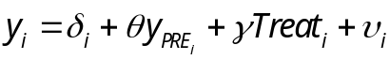
In this model,  is the baseline outcome for each individual, is the treatment effect, and allows for more efficient estimates of the treatment effect in that it statistically adjusts for the level of the outcome at baseline, while the base specifications mentioned above do not statistically adjust for the level of the outcome measure at baseline. This more efficient specification can be extended to include spillover groups by adding terms for the baseline level of the spillover group and subsequent gain score of the spillover group.

Control variables
Control variables in an estimating equation serve two purposes. First, given that treatment status is not randomly assigned, there will inevitably be sources of bias in the data that obscure the true treatment effect of CITIES activities. Wherever those sources of bias are observed, they must be included as control variables so that the obscuring effect may be partitioned away from the estimate of the treatment effect. Second, even if they don’t pose a threat to the validity of the treatment effect estimate, adding other control variables into the model helps improve precision of the estimates, making it easier to detect a treatment effect.

For the CITIES evaluation, dynamics that would need to be included in the model include current and past government and donor activity in the area of local governance, decentralization, and service delivery. Dynamics to improve estimate precision would be background variables at the individual level such as gender, age, and education, or background variables at the cluster level such as average levels of income or level of services. All variables used to apply the matching routine should also be included to statistically adjust for any remaining differences between treatment and comparison.

The evaluation team may develop additional controls as the evaluation proceeds. For example, municipal service delivery activity types and timelines induced by CITIES participation will be unique to each municipality. The estimating equations may benefit from tuning parameters that control for varying activity types and timelines captured within the same survey wave. Another example is that the progress of Jordan’s national decentralization agenda will likely depend on the nature and quality of relationships between government officials, MoI, MoMA, and MoPIC. Similarly, the progress of CITIES may depend on the quality of relationships between CITIES leadership and municipal leadership and staff. Additionally, the quality of relationships is also likely correlated with the relationships between municipalities and other layers in the local governance structure including governorate and executive councils, and with partner ministries. The evaluation team will also attempt to control for other donor activities. While respondents may not be aware of which donors fund specific activities, collecting data on and controlling for the presence of other programs will be critical for understanding potential variation between municipalities and understanding how the presence of other donors may affect key indicators.

As the opportunity arises, the evaluation team will gather qualitative information about the political economy of relationships between institutions and officials in order to help understand the implementation environment and assess its potential effects on the inferential design. This information will be collected through a qualitative data collection template and then compiled into a factor or some other quantitative data type to allow for the inclusion of these critical features of decentralization.

Evaluation indicators
MESP proposes a set of 10 evaluation indicators measuring seven primary hypotheses. Each of these have been mapped to the evaluation questions (presented here by their themes for brevity), the data source, disaggregation approach, and analysis method. Evaluation question four, Learning, is captured by the evaluation learning agenda. Annex 3 provides more detail on the specific survey questions that will measure each indicator. The proposed indicators are as follows:

Table 3 Evaluation indicators
Evaluation Question/ Theme | Hypothesis | Indicators | Data Source | Disaggregation | Data Analysis Method
1. Effectiveness | Hypothesis 1: Institutional capacity building will improve municipal operations. | - MICA Services Score  - MICA GESI Score  - Municipality Revenue  - Budget allocation to salaries | - MICA assessment data  - Available municipality administrative data  - KIIs | Municipality, district, governorate, region | - d-i-d
1. Effectiveness | Hypothesis 2: Institutional capacity building, combined with incentive grants, will improve the quality of public services. | - Availability of services  - Perceived quality/availability of services | - Beneficiary survey  - Population survey  - KIIs  - FGDs | Service, municipality, district, governorate, region, gender, age, education | - d-i-d  - d-i-d with spillover
1. Effectiveness  2. Sustainability | Hypothesis 3: Institutional capacity building, combined with proactive outreach by municipalities, will increase public perception that municipalities are responsive to citizen needs. | Perceived municipal responsiveness | - MICA assessment data  - Beneficiary survey  - Population survey  - FGDs  - KIIs | Municipality, district, governorate, region, gender, age, education | - d-i-d  - d-i-d with spillover  - Pattern/Content Analysis
1. Effectiveness | Hypothesis 4: Increased attention to marginalized groups such as youth, gender, nationality, and disability will strengthen a sense of community cohesion and resilience. | Perceived municipal effectiveness | - Beneficiary survey  - Population survey  - FGDs  - KIIs | Municipality, district, governorate, region, gender, age, education | - d-i-d  - d-i-d with spillover  - Pattern/Content Analysis
1. Effectiveness  3. Synergies | Hypothesis 5: Institutional capacity building, combined with proactive outreach and increased / improved public service delivery, will increase public perception that municipalities are effective. | Perceived ability to address common problems | - Beneficiary survey  - Population survey  - FGDs  - KIIs  - Activity and municipality documents | Municipality, district, governorate, region, gender, age, education | - d-i-d  - d-i-d with spillover  - Pattern/Content Analysis
1. Effectiveness  2. Sustainability  3. Synergies | Hypothesis 6: Improved public service delivery, increased public perception of municipal responsiveness and effectiveness, and a stronger sense of community cohesion and resilience will lead to an increase in public confidence in municipal / local governance. | - Confidence in local government  - Trust in local government | - Beneficiary survey  - Population survey  - FGDs  - KIIs  - Other activity documents | Municipality, district, governorate, region, gender, age, education | - d-i-d  - d-i-d with spillover  - Pattern/Content Analysis
1. Effectiveness  2. Sustainability  3. Synergies | Hypothesis 7: More effective public service delivery, confidence in local leadership and performance, and strengthened community cohesion and resilience will lead to a more stable and prosperous Jordan. | - Quality of life  - Composite measures | - Beneficiary survey  - Population survey  - FGDs  - KIIs  - Other activity documents | Municipality, district, governorate, region, gender, age, education | - d-i-d  - d-i-d with spillover  - Pattern/Content Analysis

Subsequent analytical reports (baseline, midline, endline) will go into additional detail about the construction of measures and indices. For example, not all data collected in the municipal institutional assessments have direct attributional links to CITIES performance, but are rather gathered for contextual purposes. In this case, the evaluation team will construct suitable indices from a subset of MICA data and use the non-performance measures as control variables (see Annex 4). Similarly, high-level measures such as effectiveness, confidence, and stability may be measured as composite indices of multiple survey items. In this case, the analytical reports will provide a detailed explanation of index construction and analysis.

Learning Agenda
The CITIES Learning Agenda operationalizes the overall Learning evaluation question, and is meant to go beyond questions of whether or not the activity worked to include insight on the mechanics of how or why outcomes were or were not achieved, and whether outcomes are heterogeneous across variation in implementation or beneficiary characteristics. According to the Office of Management and Budget:

A learning agenda is a set of broad questions directly related to the work that an agency conducts that, when answered, enables the agency to work more effectively and efficiently, particularly pertaining to evaluation, evidence, and decision-making. Once the questions are identified, a learning agenda also prioritizes and establishes a plan to answer short- and long-term questions of the highest value across relevant program and policy areas.

The USAID Bureau of Program Planning and Learning (PPL) extends this definition to describe a learning agenda as 1) a set of questions, prioritized and often organized around thematic areas, 2) a set of learning activities such as research, evaluation, literature review, stocktaking sessions, etc, and 3) a set of learning products that review and synthesize the evidence. Learning products may be accompanied by targeted and pithy communications such as infographics to highlight specific findings.

In this context, the CITIES evaluation may be seen as its own learning activity, or as a program of ongoing learning activities throughout the period of performance that will culminate with impact assessment. As learning activities cumulatively gather data, context, and insight, the evaluation team will seek to address questions that are meaningful to USAID managers and leaders and practically useful for understanding the implementation environment and supporting subsequent activity design. The table below presents the primary learning agenda questions, followed by secondary learning agenda questions.

Table 4 Primary learning agenda questions
Question(s) | What is the level of citizen awareness and knowledge of Jordan’s decentralization agenda? At what level of governance does subsidiarity [decentralization] most effectively reside—local councils, municipal councils, or governorate councils? What is the locus of control for all three levels of government?
Analytical Approach and Output | The general population survey will ask where Jordanians would turn when they require assistance, as well as other data on actual citizen preferences and behavior. Reflection on this data will include a comparison between the functions assigned to these councils by law and regulation, the functions actually executed by councils, and the actual preferences of citizens.
Question(s) | What is the sufficient dose of programmatic inputs before we see changes in municipal operations, improved service delivery, and citizen perception of service delivery? Does the combination of capacity building and incentive grants induce more, and/or more effective, investment in public services? What is the sufficient dose of institutional capacity building to induce additional investment? To what extent are these investments a function of the political context with higher levels of government or a response to programmatic inputs?
Analytical Approach and Output | In addition to a binary 1/0 treatment variable to measure the average effect on beneficiaries, the evaluation team will develop a multi-valued treatment variable that reflects the scope and intensity of programmatic inputs. Such a variable could be as simple as an activity count per area or municipality, or could be a more sophisticated construct that captures more nuance of the types and magnitudes of inputs, such as provision of office and other equipment. The analysis will then indicate a minimum level of input before outcomes are realized, or the level of input needed to reach a desired magnitude of outcome. Qualitative work and political economy analysis will provide an assessment of the decision making context that affects service delivery.
Question(s) | Is there a “J-curve” in which awareness raising drives citizen expectations, which lower perceptions of responsiveness and effectiveness until citizens see tangible improvements in service delivery? What are the relative risk/rewards in pursuing such a strategy? If there is a “J-curve,” what is the time frame before citizen perceptions improve over baseline as a result of tangible improvements in service delivery?
Analytical Approach and Output | The evaluation team will seek multiple post-treatment measurements in order to trace out a time-path of outcome trajectories – for example, the general public survey and institutional assessments will be conducted in both 2020 and 2021. This will serve two purposes: first, to identify whether there may be short to medium term deficits in outcome measures based on, for example, unrealized citizen expectations or disruption of bureaucratic processes before improvements kick in; and second, multiple post-treatment measurements will provide insight as to the time frame at which outcomes increase or attrite over time. Data collection to respond to this learning agenda question will need to occur over a minimum of three time periods to capture potential changes.
Question(s) | Does varying levels of female and youth membership in local and municipal councils affect municipal operations or service delivery? What about varying levels of female and youth employees in the municipal bureaucracy? Is there a relationship between either of these dynamics and citizen perceptions of council responsiveness and effectiveness? Does more female and youth membership of local council bodies engender increased engagement and participation among women and youth?
Analytical Approach and Output | The evaluation team will collect information on the gender composition of local and municipal councils and cross-reference this information against citizen perception and institutional capacity scores. This process will repeat for municipal bureaucratic staff. Household and beneficiary survey data will also be disaggregated by gender to see if there are differential effects of council gender composition.
Question(s) | What is the “design space” of CITIES implementation? Does it vary within or across municipalities?
Analytical Approach and Output | The evaluation team will track differences in activity implementation across municipalities and attempt to isolate whether these different design choices affected outcomes.

In addition to the questions above, the evaluation team may address the following questions based on the availability of data, client interest and available resources:

- Do characteristics of municipal and local council officials affect the distribution of services? Is there a risk of benefit capture among local elites?

- Which sequence of interventions pertaining to the “design space” best supports Activity outcomes given the limitations of the existing legal framework and political economy realities?

- What are the unintended effects of CITIES programming? Are perverse incentives introduced?

- Can increased community engagement decrease elite capture? What level of engagement is necessary for service provision outputs to better reflect the preferences of citizens?

- Can increased community engagement have adverse effects if municipal service delivery does not improve? If the locus of municipal control turns out to rest in a structure other than the municipality?

- How do service provision outputs change with the increased participation of different sub-groups such as women and youth?

The evaluation team may also develop new or modify existing questions as more is learned about CITIES implementation.

Relationship between the Learning Agenda and Impact Evaluation
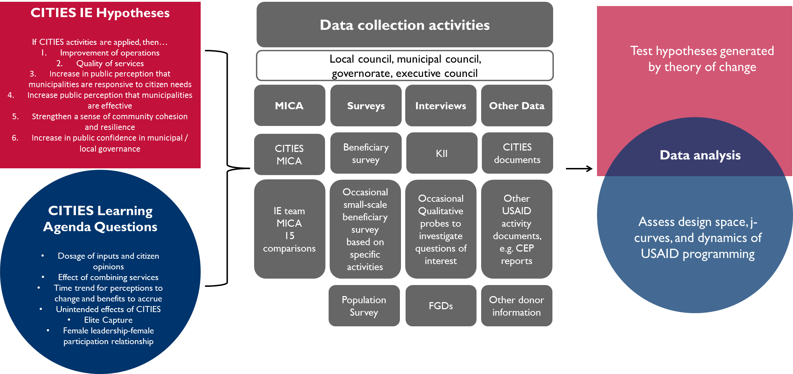
As noted above, the CITIES evaluation and learning agenda are both part of a general effort to inform and improve understanding around governance in Jordan. The visualization below provides a mapping of the questions and hypotheses for the evaluation and learning agenda, while highlighting the fact that the data inputs and analysis are shared among these two endeavors. The analytical approach employed and conclusions that come out of each will differ to some degree since the evaluation and learning agenda seek to understand similar, but distinct, aspects of local governance and service provision strengthening. The shared data collection activities, data sources, and even the overlap in analysis, particularly in qualitative methods, are important to highlight as the inputs and approach of the evaluation and learning agenda are likely to inform each other in ways that would not occur were each of these taking place separately.

Gender and Social inclusion in Evaluation
In line with USAID’s Gender Equality and Female Empowerment Policy and Automated Directives System (ADS) 205 and USAID/Jordan’s SDO4, the evaluation will consider the gender-specific and differential effects of CITIES. The evaluation team will seek to go beyond simple male/female comparisons, and analyze variation within gender groups, as well. The evaluation team will disaggregate data by gender at multiple points in the causal pathway to analyze the potential influence these effects have on the aforementioned outcomes. Different types of female respondents, including widows, young unmarried women, wives in male-headed households, and women in female-headed households, will be targeted for their perspectives, when possible. The gender approach for answering the evaluation questions also aligns with the gender-relevant learning agenda questions outlined in this design.

The evaluation team will also attempt to disaggregate data by age to see if and how youth respond to changes in municipality service delivery. Analyzing respondents along multiple dimensions may also help avoid Simpson’s paradox, wherein a trend at the aggregate level does not hold for individual groups. For example, disaggregation by gender may reveal a certain trend—such as improved perception of engagement—but this trend may paradoxically not hold across age groups. Additionally, the GESI scores used in the MICA tool will help the evaluation team track changes in how municipalities address the needs of people with disabilities and other marginalized groups.

For evaluation question 1, the evaluation team will assess perceptions of governance, public officials, and engagement by gender and age and attempt to understand what factors may have resulted in differential experiences around outcomes. Positive outcomes of CITIES activities may not reach all types of beneficiaries equally, and there may have been participation barriers that were more challenging for some municipality residents to overcome. It will be important for the evaluation team to inquire about whether activities, such as community outreach or municipal services, leave both male and female, youth and elderly, and other respondents with stronger perceived municipal institutions and more trust in their local officials. It will also be important to consider how any prior barriers to women and youth access to or understanding of municipal services, officials, and institutions, if present, may uniquely shape their opportunities to engage in new opportunities, and to participate in CITIES activities.

To answer question 2, the evaluation team will seek to understand how women, youth, and marginalized municipality residents have been engaged to create a constituency that is aware of and trusts local governance institutions. Sustainability is often a function of budgetary and administrative management, as well as on-going demand for the good or service provided (Leon 2001). The evaluation team will track gender and social inclusion differential engagement and synergies as part of evaluation question 3 through qualitative interviews and desk review of other activity documentation, as well as CITIES data and documentation.

The mixed methods approach of this evaluation will allow the evaluation team to explore various sub-groups across key outcomes and covariates, while also detailing through qualitative data the specific ways CITIES implementation led to the quantitative findings within these groups. The evaluation team will employ qualitative sampling for focus group discussions and one-on-one interviews to capture the multiplicity of experiences of marginalized constituencies, including women, youth and persons with disabilities. The evaluation team will conduct further inquiry on gender and social inclusion themes as they emerge during data analysis.

Data collection
MESP anticipates measuring the evaluation indicators and addressing learning agenda questions through three primary quantitative methods: institutional level data collection, beneficiary data collection, and general household data collection. This data will be supplemented by qualitative data collection through sector-level and issue-focused political economy probes and activity monitoring, described in more detail in the following sub-section. The evaluation team will manage all data collection activities in the comparison municipalities and for the general population survey. Beneficiary survey data collection will be managed by the evaluation team, but with close coordination with CITIES MEL lead.

The primary method will be beneficiary surveys applied where beneficiary municipality investments in operational or service delivery improvements are known. These surveys may be at the household or citizen level for public services, or among direct users of government service departments in the case of operational improvements. As CITIES’ collaboration with partner municipalities evolves into the execution of grant activities or other initiatives, the evaluation team will work with the CITIES MEL team to develop survey instruments that include questions of relevance to all parties, but do not duplicate M&E data collection internal to CITIES. CITIES municipalities’ grant activities are expected in late 2018 or 2019.
Table 5 Data collection methods and indicators
Data collection activity | Scope | Indicator(s)
Municipal assessments (MICA) | - 33 CITIES municipalities MICA scores collected by CITIES and 15 comparison municipalities MICA scores collected by MESP  - available administrative data for all municipalities | - MICA Services score  - MICA Gender and Social Inclusion (GESI) score
Beneficiary surveys | Direct ‘users’ of government services | - Quality / extent / satisfaction with govt. service, disaggregated by specific service  - Awareness of development activities / local govt. outreach in their municipality  - Perceptions of local governance  - Knowledge / awareness of local governance
Population survey | Municipality population, partitioned by direct and indirect beneficiaries within treated municipalities | - Quality / extent / satisfaction with govt. service, disaggregated by specific service and passive / direct users  - Awareness of development activities / local govt. outreach in their municipality  - Perceptions of local governance  - Knowledge / awareness of local governance

Municipal assessments will take place in early 2018, and those measures will be tracked on an occasional basis and repeated either annually or at baseline, midline, and endline. The beneficiary surveys will be concurrent with the onset of specific CITIES activities, which are anticipated to begin in late 2018 or early 2019. Once the evaluation team has a better understanding of the schedule of activities, data collection design will commence. The population survey is expected to take place in early 2018, and should repeat in 2019 and/or 2020 in order to generate treatment effect estimates and address learning agenda questions about change over time. See below for discussion of sample size and power calculations for the population survey.

The evaluation team will code direct and indirect beneficiaries in the population survey based on specific responses about activity engagement. Direct beneficiaries are respondents who participated in a donor-sponsored event; however, in some cases, people may not know who the sponsoring organization is for certain types of activities. The evaluation team will code direct engagement based on the level of involvement in an activity (e.g. attended a training), rather than by the specific activity name (e.g. USAID CEP). Indirect beneficiaries will be defined by those who live in municipalities where CITIES activities occurred, but for whom no direct engagement took place. Indirect beneficiaries could include the neighbor of someone who attended a citizen outreach event since information from the event may have been shared, but the indirect respondent did not receive any guidance directly from the implementation team.

The broader learning agenda and population survey will combine household data with implementation indicator data to track activities across Jordan and over time, with an initial plan of three survey rounds. This endeavor will allow USAID to examine variation in its programming with variation in observed outcomes, and thereby improve its programmatic design and targeting.

The overlap of the population survey with the CITIES IE, as well as baseline survey data collected by CITIES, will provide the evaluation team with data on both CITIES and non-CITIES households and communities that will inform the overall analysis and may be able to detect changes in citizen perception as a result of increased capacity and services from the municipality. Separate analytical documents will examine broader questions of USAID programming effectiveness generated by the population survey and learning agenda.

Qualitative Data Collection
In addition to activity, institutional, and survey data collection, the evaluation team will undertake qualitative data collection in the form of key informant interviews (KIIs) and focus groups during each round of data collection.

As part of the development of this design the evaluation team conducted interviews with government officials and civil society leaders who noted that the decentralization process in Jordan will not follow a predictable trajectory. The current process is seen as rife with opaque complexities, shaped by multiple stakeholders, and informal processes. To understand Jordan’s decentralization reforms, regular qualitative data collection in the form of KIIs and focus groups with stakeholders at the national, governorate, and municipal levels is necessary. Regular qualitative tracking will inform the implementation of the impact evaluation as well as bring to the fore potential limitations that might affect the Activity’s ability to achieve its outcomes.

While the impact evaluation is focused at the municipality level, systemic processes and bottlenecks at higher levels of governance are expected to affect municipal effectiveness and general performance. This is due to potential overlap between the deconcentrated structures and the lack of regulations clearly delineating their roles and responsibilities. For example, under the new deconcentrated system, municipal capital needs will be identified through a bottom-up process, but will be harmonized/reconciled at the governorate level depending on factors that are not yet identified. These factors, associated regulations, and political economy considerations will determine what needs are eventually met at the municipal level. In turn, the municipal “needs” that are eventually funded will have a direct bearing on how well the community perceives the municipality and the quality of its services. CITIES expected outcomes will therefore be affected by external factors beyond the locus of the Activity’s interventions. While some of these factors may be picked up through the quantitative measures, such as select MICA items, measurement may be more akin to a proxy rather than a direct record of high-level changes. Moreover, qualitative tracking is needed to understand and map the technical, regulatory, and relational dimensions of the various municipal functions mandated in the Municipalities Law. Tracking decentralization reforms and collecting contextual data will be important to understanding the municipalities and CITIES’ ability to improve these functions.

Key Informant Interviews
To further investigate how CITIES implementation, and decentralization efforts, services strengthening, and citizen engagement broadly, are affecting key stakeholders within municipalities, governorates, and the relevant ministries, the evaluation team will conduct select KIIs to examine relationship dynamics between:

- Municipalities and the CITIES team;
- Municipalities and other layers of the local governance structure including executive and governorate councils;
- Ministries responsible for the decentralization agenda and implementation; and
- Relevant USAID implementing partners and other donors.

These KIIs will be based around a semi-structured interview templates, depending on the identity of the stakeholder, to be developed as the CITIES implementation process proceeds. The interviews will aim to supplement the survey and activity data by capturing political economy, social, and complex contextual information that may not get measured in a quantitative survey. Unlike the other data sources, qualitative contextual data will be collected outside of the municipality-level of governance. The evaluation team will interview stakeholders at the governorate and ministerial levels to better understand CITIES interventions at these levels of governance, as well as to understand potential variation at the municipality-level that is directly related to decisions at higher levels, such as staffing and finances.

The qualitative information from KIIs will help inform the analysis of the quantitative data and assist the evaluation team in generating conclusions. The evaluation team will not be assessing CITIES implementation at the governorate and ministerial levels as this is outside of the scope of the proposed evaluation, but this information may be critically relevant for analyzing changes in MICA scores and the other key indicators. Quantitative data can help measure comparisons between municipalities, with some insight into the drivers of growth under one metric or another, while qualitative KII data may help the evaluation team explain variations in performance and pinpoint municipality staff or social changes that likely also have affected these outcomes.

The evaluation team will work with CITIES and USAID to develop a large list of KIIs across the municipalities, governorates and key ministries with the goal of stratifying by gender, where possible, as well as other key factors, to ensure a range and balance of respondent types. Stakeholders will ideally include:
- Governorate council members;
- Executive council members;
- Municipality leadership, e.g. mayor, executive director:
- Heads of Municipal Local Development Unit and Governorate Local Development Unit:
- Heads of finance and human resources, particularly those positions relevant to CITIES; and
- Community leaders, or CSO representatives.

At the ministerial level, the evaluation team would be interested in conducting KIIs with the:
- Head of CITIES Advisory Unit;
- Members of the Decentralization Ministerial and Executive Committees; and
- Head of the Fiscal Decentralization Unit, Ministry of Finance.

Focus Group Discussions
The quantitative surveys aim to capture perceptions and experiences over the course of activity implementation. The evaluation team will employ focus group discussions (FGD) to complement the analysis of the survey data and gain insight into recipient perceptions and inter-municipality dynamics with more nuance and detail than may be possible from the survey data alone. While KIIs can provide rich information to help complement quantitative data on outcomes directly related to municipal management and administration, FGDs can be an import complement for broader community, direct beneficiary and council perceptions and experiences.

The evaluation team will prepare semi-structured FGD guides that cover the key discussion topics and issues of interest. The guide will be tailored to discussant types, such as men and women, to ensure that questions are relevant and elicit honest and constructive responses. An experienced facilitator will help draw responses from the group, as well as ensure that all group discussants are able to voice their opinions. When and where possible, the evaluation team will disaggregate FGDs by sex and age to elicit honest responses. Mixed sex or age FGDs may also be used as comparison cases to test how responses vary or what themes or comments emerge in the mixed compared to disaggregated groups.

Privacy and Confidentiality Considerations

Informed Consent
The evaluation team will obtain informed consent from respondents before carrying out any data collection in households. A consent form will be used that will be translated into Arabic and then back translated into English, and piloted to ensure clarity before use in the field. Subjects will read or be read the form in Arabic. Scripts for interacting with participating households, survey instruments, focus group scripts (if applicable), and all other data collection materials are subject to ethical approval before use. Careful attention will be paid to ensure that respondents understand that their responses will be used for research purposes and are expected to be made public without compromising their confidentiality and anonymity.

Ethical Approvals
In-country approvals from the Jordanian Department of Statistics, MOMA, and/or MOI, will be obtained as needed directly by the evaluation team, and in close coordination with USAID.

Third-Party Data Sources
The evaluation team will seek out additional sources of information that may be useful for finalizing the instruments to be used in the evaluation, understanding the decentralization context, and tracking other donor activities, both USAID and non-USAID funded. This will include review of available GoJ documentation, donor activity documentation, survey instruments from other relevant studies, and data from the Department of Statistics and other donor activities, where available.

Implementation Fidelity
Ensuring that the basic assumptions about implementation hold is critical to the internal validity of any evaluation design. The evaluation team will undertake regular implementation fidelity checks to ensure that any potential risks to the validity of the design are discovered quickly and any changes in implementation, from actual activities and scope to the general timeline of CITIES, are discussed early enough to address in a methodologically sound manner.

The risks of ignoring implementation fidelity range from potentially misunderstanding aspects of activities to increasing error in estimates and reducing the effect size that analysis detects. To avoid these issues, the evaluation team will need access to the regular reporting of CITIES (e.g. quarterly and annual reports). The evaluation team will work with USAID and CITIES to develop a plan to schedule regular, one-to-two times a quarter check-ins with the CITIES staff to address any potential challenges or changes based on review of the quarterly reports and follow-up on developments in the municipalities. The evaluation team may also work with CITIES and USAID to schedule visits to treatment group municipalities to meet with municipal staff, such as the head of finance, executive director, mayor, head of human resources, and other relevant leaders, to see how implementation on the ground compares to planned and reported activities.

The table below shows illustrative activities, the parties involved, and the frequency for implementation fidelity. This kind of coordination plan will need to be agreed upon by CITIES and USAID.
Activity | Description | Parties Involved | Frequency
Status Updates | Formal discussion of implementation and evaluation progress, highlight changes, discuss potential next steps or updates. | USAID, CITIES DCOP/MEL lead/Component Leads, MESP IE team | Quarterly
Implementation Tracking | Work with MEL team to develop tracking inputs. This will be a one-off meeting initially and then incorporated into the quarterly status updates. | CITIES MEL lead, MESP IE team | Annually
Document Distribution | Sharing of implementation documentation, such as municipality reports and work plans. | USAID, CITIES COP, MESP IE team | Monthly
MICA synthesis | Shared review of MICA scores between implementation and comparison areas to ensure consistent implementation of the tool and to walk-through updates or changes enacted by CITIES | CITIES Component 1 lead, MESP IE team | Annually
MEL Data check | Review of municipal rosters, Component 2 HR audits, Component 1 MICA data, other MEL data. Share data from surveys, activity monitoring, municipality tracking, and other activities; the evaluation team will then input this data as part of their regular tracking for analysis | MESP IE team, CITIES MEL team | Quarterly
Fidelity Interviews | Brief KIIs with municipality administration and leaders to understand implementation adherence, delivery, and differentiation. | MESP IE team, CITIES MEL team | Annually

The goal of implementation fidelity is not to evaluate CITIES implementation through some additional approach or make planned versus actual judgments, but rather to ensure that if and when changes to implementation occur, the evaluation team can adequately and accurately account for them in their analysis and design. Any qualitative fidelity interviews with municipality staff will follow a semi-structured format based on a general interview template to be developed based on review of the CITIES work plans. The quarterly check-in calls with CITIES will be unstructured and allow both the evaluation team and CITIES staff to openly discuss potential challenges and progress on both sides.

Analysis

Matching municipalities
In the absence of randomizing the assignment to treatment, grouped data by beneficiaries and non-beneficiaries is not directly comparable due to observable or unobservable differences between groups in addition to treatment status. One wishes to know how the treatment effects beneficiaries, but cannot be sure if any observed group differences are driven by treatment or some other observable or unobservable difference between groups.

A common tactic is to use observable characteristics to attempt to adjust for these differences and thereby generate “as-if” random assignment allowing a direct comparison of the outcomes between the two groups as the estimate for activity impact. Under this approach, researchers create pairs between each implementation unit and a comparison unit on the exact same observed characteristics; however, this can quickly become onerous and difficult if the number of observable characteristics required to find one-to-one matches is large. One alternative method of applying this tactic is to select a sub-sample of your data beforehand using Propensity Score Matching (PSM). Under propensity score matching, a select number of observable characteristics are used to generate a predicted probability of belonging to the treatment group. This predicted probability (the propensity score) is then used to match treated and comparison units based on the theorem that if they match on the score generated from observable characteristics, they essentially match on the specific values of the observable characteristics as well.

If matched treated and comparison units have nearly identical propensity scores (or the overall propensity score for each group is nearly identical), then there should also be balance on the observable characteristics used to generate the score. Ideally, a successful propensity score matching routine would also generate balance on other observable characteristics even if they were not used to generate the propensity score.

Most crucially, a successful propensity score matching routine is assumed to have also balanced the groups on any unobservable characteristics that differ by group and are correlated with both the treatment assignment and the outcome. The validity of subsequent treatment effect estimates rests upon this assumption, and it is up to the evaluator to justify the assertion that such balance has been achieved.

USAID established several criteria for selecting beneficiary municipalities, which become prime candidates for matching treated with comparison units. According to the CITIES solicitation, these criteria were the following:
- 50% of the municipalities should be heavily impacted by the Syrian crisis
- 25% should be historically marginalized politically/economically/or socially
- 25% should be high potential urban areas
- The presence of “poverty pockets”
- Opportunities to support “positive deviants” and change agents
- Financial resiliency, including information on their budget status, per capita revenue, etc.
- Capacity to implement alternative income-generating initiatives based on their previous efforts involving other donors
- The articulation of a vision – including economic priorities and capacity development efforts – for the municipality that complements the objectives of USAID CITIES
- Demonstration of commitment to local participation to ensure the successful implementation of CITIES vis-à-vis the support from political leadership

To operationalize these criteria, CITIES gathered available information at the municipal level and examined data on the following indicators:
- Total population
- Refugee population
- Poverty rate
- Presence of Community Engagement Project (CEP) activities
- Presence of World Bank Emergency Services and Social Resilience Project (ESSRP) activities

CITIES selected 33 municipalities to participate based on these and other criteria. The table below presents the balance on the key matching variables of population (Class), refugees population, poverty, and the presence of similar programming (CEP from USAID, ESSRP from World Bank). Class A municipalities are not included, as all except one are participating in CITIES. This leaves a total of 23 CITIES municipalities and 66 comparison municipalities from which to identify appropriate matches.
Table 6 Initial balance across treatment and comparison, Class B-D municipalities
Measure | Treatment | Comparison | Difference
Log population | 10.11 | 9.90 | 0.21
Refugee population | 0.15 | 0.08 | 0.07
Poverty rate | 0.32 | 0.17 | 0.15
CEP | 0.22 | 0.12 | 0.10
ESSRP | 0.35 | 0.03 | 0.32

Note that CITIES municipalities have higher poverty rates and refugee populations, as directed by USAID. CITIES municipalities are also slightly larger in population and are more likely to have other, similar activities going on concurrently with CITIES. There is imbalance on all of these key matching variables that must be addressed if comparison municipalities may be used as a counterfactual for treatment municipalities.

Additional variables used to inform beneficiary municipality selection included per capita income for Jordanians and refugees, an institutional financial independence score, percentage of municipal budgets devoted to salaries, and percentage of municipal budgets devoted to capital expenditures. While these are valuable indicators, data were not complete for all municipalities, quality was uncertain, and it was not clear that additional criteria applied to a very limited pool of 89 municipalities would be able to substantively improve the quality of matches. Therefore, these additional criteria were not considered during the treatment and comparison municipality matching process.

For the purposes of matching, the five indicators listed above were considered the primary matching criteria, along with municipality class, governorate, and region. After running multiple models using PSM and examining the quality of matches, a model was selected that explicitly matched on the five primary selection criteria, plus region. This selection matched one comparison municipality for each of the 23 treated municipalities, for a total of 46 candidate municipalities for data collection activities.

However, based on time and cost constraints, the evaluation design called for data collection in 15 in each of the 23 selected treatment and comparison municipalities. This provided an opportunity for a second matching step in which the 15 closest treatment-comparison matches were selected, for a total of 30 municipalities for data collection activities. Propensity scores were again estimated for the group of 30 municipalities in order to assess balance.

The figure below shows the distribution of propensity scores, interpreted to mean the predicted probability that the given unit belongs in the treated group, for each stage of unmatched municipalities, the first match of 46 municipalities, and the second match of 30 municipalities. The goal is generate matches such that the distributions show significant overlap across treatment and comparison, indicating a general equality of average propensity scores across the two groups.

Figure 7: Distribution of propensity scores across treatment and comparison groups
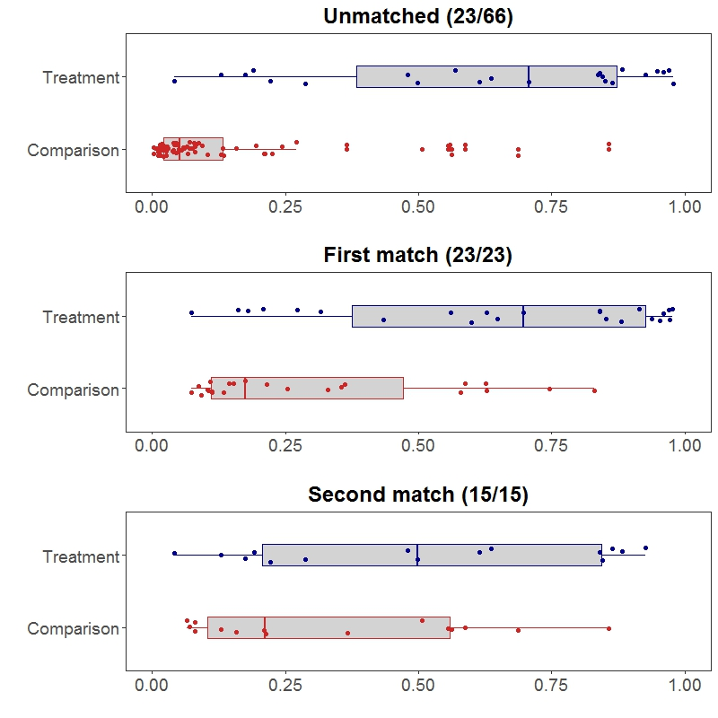
Among the original 89 municipalities to be matched, there is overlap among some units but lack of overlap among others. Propensity scores for comparison municipalities are clumped near zero and do not exceed 0.8, i.e. an 80 percent probability that municipalities would receive the CITIES intervention given the observed matching variables, while there is a smaller clump of treated units with propensity scores higher than 0.8. In the first match of 46 municipalities, there is significant improvement in overlap in that the comparison units with low propensity scores were removed. However, there are still several treated units with propensity scores higher than 0.8 without close matches among comparison units. In the final match of 30 municipalities, the distributions show even more overlap but there is still some imbalance, with relatively more comparison units with low propensity scores, and more treated units with high propensity scores. One may conclude that the two-stage matching routine greatly remediated but did not fully solve the problem of imbalance across treatment and comparison municipalities.

In order to see that the propensity score matching has achieved balance on observable characteristics, and thereby hopefully achieving balance on any unobservable characteristics, the variables are transformed into standard deviation units and listed below in terms of how the treated and comparison group values differ from one another. The desired level of difference is zero, indicating full balance across groups. Differences within 0.1 standard deviations are generally considered to be within an acceptable margin of imbalance. Differences between 0.1 and 0.25 are considered more worrisome, but still tractable and able to generate defensible treatment effect estimates in conjunction with additional statistical adjustment. Differences beyond 0.25 are considered to be definite threats to the validity of treatment effect estimates, and unable to be resolved by propensity score matching routines.
Figure 8 Standardized differences across selected treatment and comparison municipalities
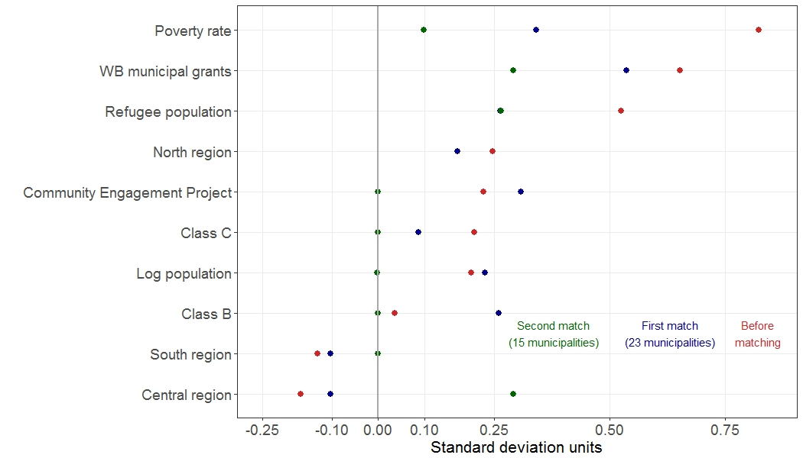

In the figure above, one can see severe imbalances in the original set of 89 municipalities (red dots), most notably the poverty rate. There is significant improvement in balance within the first match of 46 municipalities (blue dots), and further improvement in the final set of 30 municipalities (green dots).

It should be noted that based on USAID’s criteria and CITIES’s assessment of the current environment, poverty rate and refugee population are considered the two most crucial attributes that must be balanced across treatment and comparison groups. In the final set of 30 municipalities, the treatment-comparison difference in the poverty rate is 0.1 standard deviations, and 0.26 for refugee population. The full table of distances across the three sets of municipalities is below.
Table 7 Standardized differences across municipality characteristics
Measure | Unmatched  (23/66) | First Match  (23/23) | Second Match  (15/15)
Poverty rate | 0.82 | 0.34 | 0.10
WB municipal grants (ESSRP) | 0.65 | 0.54 | 0.29
Refugee population | 0.53 | 0.26 | 0.27
North region | 0.25 | 0.17 | -0.26
Community Engagement Project | 0.23 | 0.31 | 0.00
Class C | 0.21 | 0.09 | 0.00
Log population | 0.20 | 0.23 | 0.00
Class B | 0.04 | 0.26 | 0.00
South region | -0.13 | -0.10 | 0.00
Central region | -0.17 | -0.10 | 0.29

Based on discussions with local staff and general assessments, regional differences are not considered validity threats once poverty and refugee population are balanced. This leaves refugee population and the presence of a World Bank municipal resiliency project as definite threats to validity without additional statistical adjustment.

The evaluation team will address these threats in two ways. First, refugee population and activity presence will be entered as control variables in the estimating equations, thus partitioning any influence of these variables away from the estimate of the treatment effect. Second, MSI will apply another round of matching post-hoc, after the baseline data has been collected. This post-hoc matching will not select additional sub-samples, but will rather generate a set of weights that in aggregate will ensure full balance across treated and comparison units.

With these additional statistical adjustments and qualitative assessment, the final set of 30 treatment and comparison municipalities is considered to be sufficiently balanced across treatment and comparison units as to merit analysis for achieving outcomes. However, given that the matching routines were applied to a small candidate pool with limited ability to provide close matches, it is best to consider municipal institutional assessments from the point of view of comparative case analysis in which qualitative features of treated and comparison units will be crucial for contextualizing the evaluation findings as noted earlier.

See Annex 5 for the listing of selected treatment and comparison municipalities, along with core balance metrics.

Sample sizes and statistical power
For any data collection endeavor that seeks to answer a hypothesized question, it is imperative to design the study with the strength to competently address the question. This is the realm of sample size power calculations, which prospectively estimates the probability of finding a statistically significant result if there were in fact a genuine treatment effect. In low-powered studies, even a statistically significant finding may be called into doubt with low sample sizes. Even worse, low-powered studies may not find a treatment effect even if there were one, leading stakeholders to erroneously conclude that the intervention was a failure. It is generally better to refrain from data collection rather than launch a low-powered study, or such data collection must be labeled as exploratory and not used for inference.

With regard to the three streams of data in the CITIES evaluation (see Table 5), sample size calculations do not apply to municipal level data that is administrative in nature and not based on sampling. Sampling size calculations are also less relevant for the beneficiary level data collection, in that they will be ad hoc and driven by the extent of CITIES activities to improve services and outreach. For the population-based survey which intends to measure changes in citizen perception, power calculations are necessary.

Sample size and power calculations for the population-based survey are complicated by the fact that the survey intends to be representative across Jordan (and not restricted to CITIES treatment and comparison municipalities), collect data on other USAID indicators, support a learning agenda to help the mission better understand its programming environment, and possibly even conduct inference on other programming. The discussion on power in this section is oriented toward the CITIES evaluation – see separate documentation for sampling design of the population survey beyond the CITIES evaluation.

The population-based survey component of the CITIES evaluation is expected to follow a multi-stage stratified cluster sampling design. The first sampling strata will be at the region or governorate level, followed by a random selection of municipalities within each strata, a random selection of census-based population clusters (typically consisting of approximately 200 households) within each municipality, a random selection of 10-12 households within each cluster, and finally a random selection of eligible adults within each household. For the purposes of the CITIES evaluation, respondents are further classified by direct beneficiary, indirect beneficiary, or non-treated respondent within CITIES municipalities, or simply a comparison respondent within comparison municipalities. The following figure illustrates the respondents’ classification in the study.

Figure 9 General sampling design for the population survey
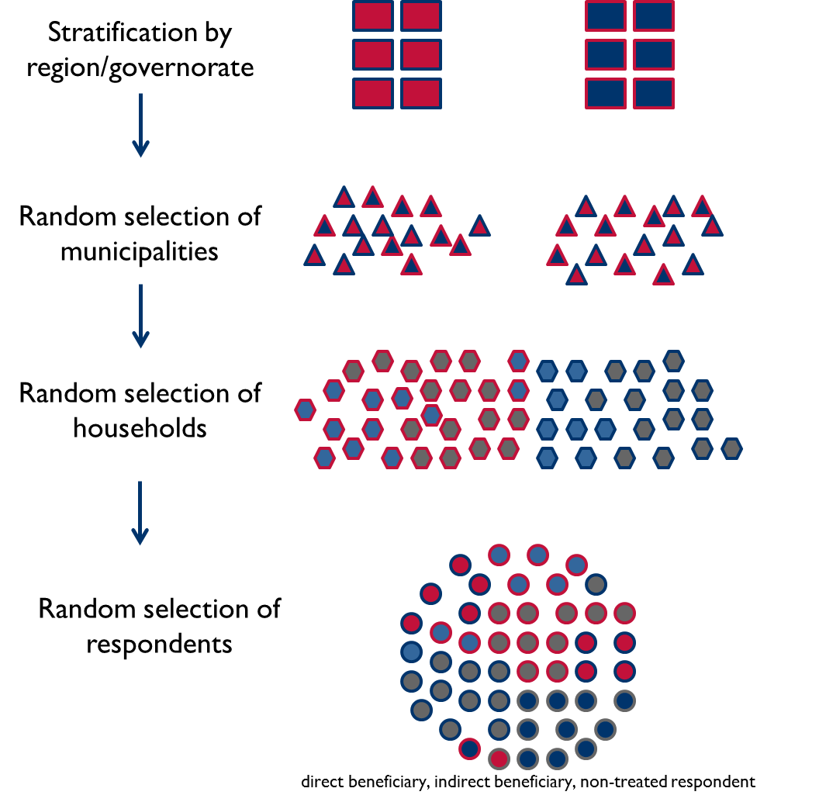

What sample size is needed in order to detect a given treatment effect as statistically significant? Under randomization of treatment status to individuals, a simple difference of 0.2 standard deviations in the outcomes between randomly selected individuals from treatment and control groups would typically require no fewer than 400 respondents for each group. Considering a scenario of treatment assigned to a few neighborhoods or blocks within a beneficiary municipality, and direct beneficiaries nested within these neighborhoods or blocks, there will typically need to be approximately 40 neighborhoods or blocks allocated to treatment and control, and no fewer than 20 respondents per neighborhood or block.

These general parameters for power calculation are greatly simplified and utilize a number of general assumptions about the data generating process and properties of the data. However, an observational study where the CITIES partner municipality selection is not randomly assigned will encounter correlated data across observable and unobservable characteristics as well as heterogeneity across different units of treatment. For these and other reasons, it is advisable to directly model the study and intervention data generating process whenever feasible, in order to make direct estimates of power based on specific parameter ranges provided by expert knowledge and/or prior data samples related to the intervention.

MESP has access to such data through the Community Engagement Project (CEP) evaluation. As a part of that exercise, in 2016 MESP conducted a survey of 1,589 respondents in 20 municipalities – some of which are CITIES municipalities. This survey contains measures that could be construed as indicators for CITIES, and are therefore valuable in helping model the CITIES evaluation. The table below lists a selection of such indicators.
Table 8 Indicators from CEP survey
Measure | Mean | SD
Aware of government training / engagement | 0.194 | 0.40
Aware of local development activity | 0.255 | 0.44
Municipal responsiveness | 0.647 | 0.48
Mayor responsiveness | 0.704 | 0.46
Local decisions informed by citizen perspectives | 0.434 | 0.50
Jordan heading in right direction | 0.417 | 0.49
Communities able to solve own problems | 0.121 | 0.33
Municipal officials trustworthy | 0.512 | 0.50

The data can also be used to crudely test the generic development hypothesis that local government engagement and development activities strengthen citizen perceptions of responsiveness, effectiveness, and overall legitimacy. In the CEP data, respondents who report awareness of local government engagement are 14 percent more likely to consider their municipality to be responsive (p=.002), and female respondents are 6.8 percent more likely to consider their municipality responsive relative to men regardless of whether they are aware of local engagement. Similarly, respondents who report awareness of a local development activity in their community are 8.8 percent more likely to consider Jordan to be heading in the right direction (p=.002), and female respondents are 7.8 percent more likely to consider Jordan heading in the right direction regardless of whether they were aware of a local development activity. These data could serve as preliminary estimates in prospective power calculations.

In the case of the CITIES evaluation, there are two sources of uncertainty specific to the design. The first novelty is that the evaluation team is not able to directly manipulate the sample sizes for beneficiaries, when beneficiaries are a subset of the population. Beneficiary sample sizes are then a function of the number of CITIES municipalities selected by the population survey sampling plan, the number of respondents per municipality, and the reach of CITIES activities to municipal populations.

From a population-based survey, consider a CITIES beneficiary sample to be drawn from 10-25 CITIES municipalities, at a sample of 150-250 respondents per municipality, with the sample composed of 10-40 percent direct beneficiaries and an additional 10-20 percent indirect beneficiaries. A simulation of 10,000 possible sample sizes based on these parameters suggests that a population-based survey of 8,000 – 12,000 respondents would generate a sample of 1,000 direct beneficiaries and 500 indirect beneficiaries. The following figure illustrates the distribution of possible sample sizes.

Figure 10 Distribution of CITIES sample sizes from population survey, from 10,000 simulated draws
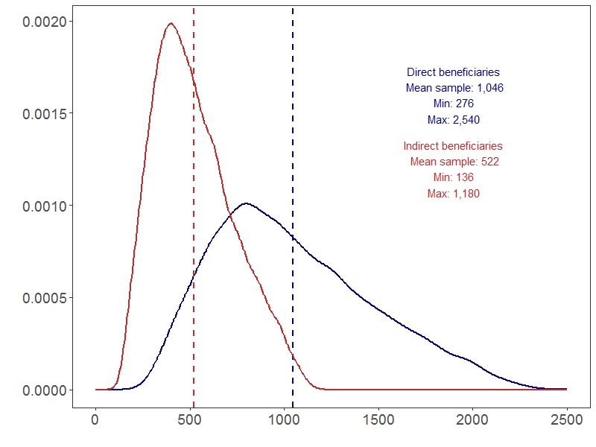
These simulated draws represent the treatment group of CITIES beneficiaries, and would be compared against a much larger comparison group. If data are aggregated to clusters, there would likely be at least 60 treated clusters within CITIES municipalities.

Are these simulated sample sizes sufficient for detecting a treatment effect? Conventional power analysis would suggest yes, especially in the case of repeated measures of cohorts such as clusters or municipalities. But with available data from the CEP survey, it is possible to simulate power directly. Using the municipal responsiveness variable as the illustrative outcome, the evaluation team programmed a statistical routine adapted from the power simulation presented by the Evidence in Governance and Politics (EGAP) center at University of California at Berkeley. One scenario uses only the outcome, while another scenario includes a hypothetical control variable of gender. The effect of gender was set at eight percent, consistent with the CEP survey data. Five hundred (500) simulations were then run for each sample size from 50 to 3,500 in steps of 50. This produced the following power curves.
Figure 11 Simulated power curves based on CEP data
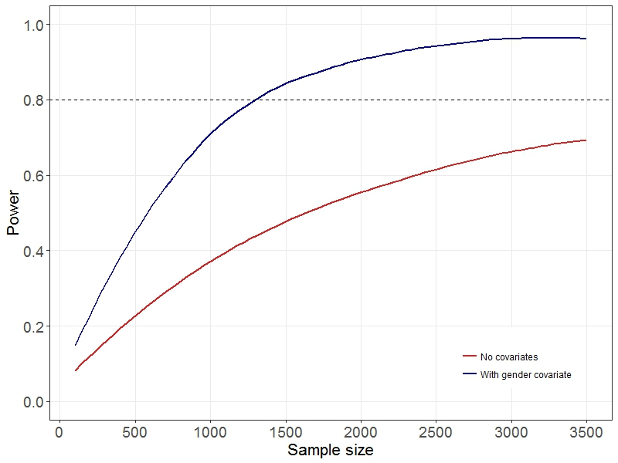
The CITIES evaluation is under-powered using only the outcome, but sufficiently powered at a sample size of approximately 1,200 if covariates are used. This simulation does not directly model the intention to repeat measurements, which will increase power, but the inclusion of a covariate that helps predict outcomes shows the effect. Adding contemporaneous characteristics such as gender or including pre-treatment outcome measures encompass a range of different designs but have the same beneficial effect of capturing variance in the outcome and therefore improving statistical power to isolate a CITIES treatment effect.

These calculations may be updated as more information becomes known.

Qualitative Data Analysis
The evaluation team will analyze transcribed data from the FGDs and KIIs using content analysis techniques, in which text will be coded according to key themes of interest across the interviewees and discussion participants. The team will summarize responses related to each theme and include quotations from respondents to illustrate key findings. This will include highlighting “outlier” responses and experiences, such that the range of responses will be captured in the summary write-up. The team will also make planned/actual comparisons in answering evaluation question1question 1. The evaluation team will make comparisons between activity descriptions, work plans, targets, and periodic performance data to inform the examination of CITIES’s performance relative to overall perception of the activities. Throughout the analysis phase, the team will identify where male/female and youth/adult responses and experiences appear to be parallel and where they differ, for example with respect to civic engagement, outreach efforts, understanding of municipality’s roles in services.

The team will conduct qualitative data analysis on FGD transcripts using MaxQDA or a similar program. The evaluation team will analyze data within strata and types (e.g., South region female) and then across strata and types (e.g., South region female data from KIIs and FGDs) to develop a thorough understanding of responses, address contradictory findings, and highlight common themes and narratives. The evaluation team will code all interview notes and transcripts with a two-pronged approach using the analysis software. First, it will develop a set of ex-ante themes to use in coding responses based on the evaluation questions and knowledge of CITIES. Open coding will then capture themes and broader trends as they emerge during a review of the data and will be grounded in the text of the documents. The team will further refine its analysis approach through follow-up coding that will assess themes between codes and potentially applying a hierarchical approach wherein codes are grouped and sub-grouped by evaluation question or topic area.

The team will triangulate coded segments and perform analysis of findings to inform conclusions from the survey data. Additional text mining analysis methods may also be employed, such as phrase categorization and quantification to highlight areas of emphasis or key themes from the FGDs and KIIs.

Strengths and Limitations
The scope of the CITIES activity presents several challenges and opportunities to assess the impact of the local service provision and governance strengthening. The proposed evaluation as described in this document is expected to make an important contribution from the standpoint of both the learning and accountability objectives of the USAID Evaluation Policy.

The strengths of the evaluation design are expected to include:
- Study design. The expected use of a PSM design will provide rigorous estimation of the CITIES activity attribution to the outcomes of interest, minimize some of the bias from unobserved factors, and add to the evidence base on DRG interventions, an area where only a limited amount of research has been conducted. Using a PSM design coupled with the learning agenda will allow for the evaluation to maintain its internal validity while adjusting to potential contextual changes among the municipalities and understand not just what impact occurs, but also why.

- Geographic and data collection scope. The geographic scope of this IE will allow the evaluation team to see how decentralization and local governance efforts affect institutions (through the MICA score) and people across Jordan. Examining 15 comparison municipalities, plus the matched CITIES municipalities, this study could help inform potential decentralization interventions in the future and provide an understanding of how regional variation may affect outcomes. In addition, the broad use of different data sources within the evaluation design provides a robust view of CITIES effect on municipalities. Evaluation designs often include either a small sample of qualitative interviews or quantitative household surveys. However, this design includes both, as well as the use of administrative data to better understand activity impacts.

- Policy relevance. A rigorous evaluation of the CITIES activity will provide a strong base of support for the ways policy makers can address local governance reform, especially for the GoJ as it tries to promote decentralization. While there are limits to what can be claimed from a single evaluation, this IE may help fill gaps in the current evidence base on governance interventions.
However, a number of limitations of the evaluation design should be borne in mind. Some of the main anticipated challenges, along with how they may be addressed by the evaluation team, are described briefly below.
- Failure to capture a true baseline. In some municipalities, CITIES has completed its assessments and initiated activities for municipalities and citizens. If any of these municipalities are included in the baseline measurements, then those activities pose a potential threat to the validity of the evaluation measures. In the event that a substantive difference is found between treatment and comparison municipalities, the evaluation will need to investigate whether CITIES activities that pre-date the baseline could account for the difference.

- Unobservable factors. The success of any governance intervention is a combination of activity inputs, motivated local participants, incentives, and various other factors related to the political economy of local government (e.g. relationships). In a randomized evaluation design, where unobservable factors can be confidently balanced between treatment and comparison groups, these issues may prove less influential in the final estimates of activity impact. However, given the nature and approach of the CITIES IE, the evaluation team cannot simply assume that unobservable factors will be averaged out across groups. Indeed, capturing the political economy of implementation and local governance is a daunting task and one that will surely affect the success of some aspects of CITIES implementation. Measuring and accounting for these factors will be critical to the extent that it is possible to do so. The evaluation team will work with CITIES staff and USAID to understand what local factors may not be captured in quantitative data collection. This may include developing a qualitative data collection template that can be translated into a quantitative index to serve as a control variable, or simply involve triangulating qualitative data with documentation and quantitative data to better understand why and how certain outcomes were achieved.

- Recency and recall biases. The evaluation team will utilize administrative and implementation data, such as MICA scores, for its estimation of CITIES impact. However, a large portion of understanding how decentralization is progressing involves asking people about their perceptions of how decentralization is progressing. This creates several challenges. Notably recency bias, where in people remember whatever has happened most recently, whether good or bad, rather than what has occurred over a certain period of time. Recency bias can be an issue even when questions are asked about, “the past 12 months.” Similarly, recall bias relates to the fact that people do not always remember what activities have taken place or the details of their involvement. For example, people may not recall that municipal leaders held outreach events or introduced new street cleaning activities if they did not occur in the proximate past. The use of multiple data sources, as well as multiple data collection periods, will help mitigate some of the effects of these biases. The use of well tested survey instruments can also help improve responses and diminish the potential risk these biases pose.

- External validity. The nature of the CITIES activity imposes limitations on the external validity of the evaluation (i.e., the extent to which the evaluation findings can be expected to predict the impacts of a program like CITIES undertaken in a different country or in Jordan at some point in the future). First, as noted in the background section, Jordan has undergone multiple institutional reform efforts and it is likely that changes to the local governance context will continue to evolve. The results from this IE may not hold in a future context or even at a different governing-level. Secondly, any results from an IE come with critical caveats that often get forgotten in the shadow of key findings. The evaluation team will strive to make the limits and exceptions of their analysis clear. Causal attribution can be highly sensitive to underlying assumptions and analytical specification. The extrapolation of the IE results to a broader understanding of decentralization efforts may not be valid and should be informed by detailed understanding of this report.

Data Management Plan

File Architecture
The final evaluation outputs will have a well-organized folder structure and clear, descriptive, and unique file names. The evaluation data and the information derived from it will be organized and archived in files that can be easily reviewed, audited, reused, and shared among relevant stakeholders.
The file architecture will be designed depending on type of data collected, analyzed, and reported. All data will be sorted and organized according to the mechanism used to generate it, such as spreadsheets resulting from survey questionnaires, and transcripts and notes from interviews. Given that this evaluation’s timeframe will extend past the end of the MESP contract, the evaluation team will ensure that all files are organized to allow for easy and accessible transfer.

Data Storage and Backup
All final data generated from this evaluation will be deposited in a unified, cloud-based digital repository such as Egnyte. The backup of the dataset and deliverables will be kept in a separate drive in-house. This will ensure that all data are easily captured and that members of the evaluation team have immediate access to the data as necessary. All data collected at the field level will be managed by the evaluation team and overseen by MESP.

Data Format and Sharing
The evaluation data and information will be converted to the appropriate formats and shared with USAID per Automated Directives System (ADS) 579 requirements and guidelines. To ensure transparency and replicability, all data will be submitted as annotated datasets clearly defined with codebooks and annotated analysis of files.
Structured quantitative data will be stored in a non-proprietary, machine readable (.csv) format. Metadata will be generated in the form of codebooks and data summaries. Unstructured qualitative data, such as interview transcripts, will be stored in text-based data entry templates. The final, anonymized dataset will be compiled and submitted to the USAID Development Data Library (DDL) in accordance with ADS 508 and ADS 579.
Data Succession Planning and Handover
This evaluation plans for data collection that extends into 2021, while the current MESP contract expires in November 2018. MESP will prepare a handover memo with all accompanying documents and data after delivery of the baseline evaluation report, which is expected in July 2018.

Conclusion

Next Steps and Products to be delivered
Upon approval of this design proposal, the evaluation team will launch the institutional measures in comparison municipalities, generating a listing of key informants to be interviewed, development of qualitative data collection instruments, and finalizing the scoping and launch of the general population and beneficiary surveys. This data collection process will take place in early 2018.

Based on analysis of these data collection activities, the evaluation team will produce a baseline report from the institutional measures in 30 treatment and comparison municipalities and the household survey data that is relevant to CITIES. The baseline report will be informed by separate assessments from two subject matter experts in local governance and decentralization. In addition to the baseline report, the evaluation team will seek to develop data products highlighting key findings.

Evaluation team members and roles
The evaluation team conducts its work under the general guidance and leadership of Ali Hayat, MESP Chief of Party. The CITIES evaluation team consists of six members:
Table 9 CITIES evaluation team
Member | Role | Areas of focus
Dan Killian | Team Lead | Evaluation design, analysis, and reporting. Coordination of tasks of team members.
Jacob Patterson-Stein | Evaluation Specialist | Evaluation design, analysis, and reporting. Ad hoc tasks as required.
Dima Toukan | Subject Matter Expert, Decentralization Policy | Qualitative tracking of municipalities and the political economy of relationships; analysis and reporting.
Owen Goldfarb | Subject Matter Expert, Local Governance | Ensure quality and consistency of institutional capacity scoring in comparison municipalities; general support to evaluation
Peter Fricker | Subject Matter Expert, Decentralization Practice | Ensure quality and consistency of institutional capacity scoring in comparison municipalities; general support to evaluation

A rough timeline is included below. However, note that the population survey is still in the scoping phase so the timeline is tentative until firmer planning is possible.

Timeline of tasks for baseline
Figure 12 Population survey implementation schedule
CITIES Baseline Survey | January |  |  |  | February |  |  |  | March |  |  |  | April |  |  |  | May |  |  |  | June
CITIES Baseline Survey | 1 | 2 | 3 | 4 | 1 | 2 | 3 | 4 | 1 | 2 | 3 | 4 | 1 | 2 | 3 | 4 | 1 | 2 | 3 | 4 | 1 | 2 | 3 | 4
Learning Agenda
Meet with USAID mission staff and other stakeholders
Generate hypotheses and learning agenda questions
Map survey instrument questions to hypotheses and questions
Design strategies to test hypotheses and questions
Institutional assessments
Collaborate with CITIES team for assessment training
Shadow CITIES’ application of MICA
Approach comparison municipalities for participation
Engage central ministry for buy-in
Apply MICAs in comparison municipalities
Population survey
Finalize survey instrument draft
Incorporate learning agenda consultations
Cognitive pre-test
Field pre-test
Revise survey instrument
Survey field work
Delivery of data
Data analysis
Deliver reports and data products

Beneficiary and qualitative data collection survey
Finalize survey instrument draft
Coordinate data collection with CITIES
Cognitive pre-test with CITIES MEL team
Field pre-test
Revise survey instrument
Survey field work for beneficiary survey
Qualitative interviews and FGDs
Delivery of data
Data analysis
Deliver reports and data products

Annexes

Annex 1: Selected bibliography
Background

About Jordan: Local Government. Jordanian Embassy, Canberra.

Jordan - Third Tourism Development Project: Annex B. “Analysis of the Municipal Sector.” World Bank, 2005.

Jordan Towards a New Partnership With Citizens: Jordan’s Decentralization Reform. OECD Open Government Review. 2017.

Municipalities and Issue of Local Governance In: Atlas of Jordan: History, Territories and Society. Ababsa, Myriam. Beyrouth: Presses de l’Ifpo, 2013.

The Redeployment of State Power in the Southern Mediterranean: Implications of Neoliberal Reforms for Local Governance. Bergh, Sylvia, Routledge: 2016

Causal inference and evaluation design
Beyond Baseline and Follow-up: The Case for More T in Experiments. David Mackenzie. World Bank, 2011.

Beyond Power Calculations: Assessing Type S (Sign) and Type M (Magnitude) Errors. Andrew Gelman and John Carlin. Perspectives on Psychological Science, 2014, Vol. 9(6) 641-651

Change Scores as Dependent Variables in Regression Analysis. Paul Allison, Sociological Methodology, Vol. 20 (1990).

Text mining infrastructure in R. Feinerer, K. Hornik, and D. Meyer. Journal of Statistical Software, 25(5): 1-54, March 2008. ISSN 1548-7660.

Decentralization, local governance, and community development
A Critical Review of Community-Driven Development Programmes in Conflict-Affected Contexts. Elisabeth King. January, 2013.

GoBifo project evaluation report: Assessing the impacts of community driven development in Sierra Leone. Katherine Casey, Rachel Glennerster, and Edward Miguel. October, 2013.

MISTI Stabilization Trends and Impact Evaluation. MSI and D3 Systems. November, 2015.

Four pillars of financial sustainability. Patricia León. Arlington, VA: Nature Conservancy, 2001.

Randomized Impact Evaluation of Afghanistan’s National Solidarity Programme. Andrew Beath, Fotini Christia, Ruben Enikolopov. July, 2013.

Thinking Small: The United States and the Lure of Community Development. Daniel Immerwahr. Harvard University Press, 2015.

Annex 2: Select Activities Aligned with CITIES Goals

Jordan Emergency Services and Social Resilience
The JESSR is a $63.5 million project, led by the World Bank that was started in October 2013 to help Jordanian municipalities and host communities address the immediate service delivery impacts of Syrian refugee inflows and strengthen municipal capacity to support local economic development. The project has two components. The first being municipal grants. The grants allow municipalities to finance additional public services and programs necessary to meet increased demand stemming from the arrival of Syrian refugees in their community. Specifically, the grants provide tangible support to municipal services through interventions in the sectors of solid waste management (SWM), public roads, public lighting, sanitation and public leisure spaces. Through the institutional development and project management component the project will provide technical assistance to municipalities allowing them to efficiently and effectively use awarded grants, as well as to engage with communities, identifying and prioritizing their needs and plan future investments in accordance. As such, this second component seeks to reinforce social infrastructure by specifically improving communication between municipalities and citizens through, inter alia, town-hall meetings, participatory and institutionalized planning processes and strengthened accountability mechanisms. The rationale of the project suggests that improvements in these areas will demonstrate municipalities’ ability to respond to the needs of the community, thereby increasing confidence in the capacity and functioning of local government institutions. Increased confidence in these institutions, coupled with more effective service delivery, is anticipated to reduce tensions and strengthen social cohesion and resilience.

The project will close in December 2017.

Civic Initiatives Support Program (USAID CIS)
Implemented by FHI 360, CIS is a five-year, $40 million program that aims to cultivate a strong and vibrant civil society in Jordan by supporting a broad range of civic initiatives. Working at both national and local levels, CIS provides assistance for civic initiatives and advocacy efforts; endeavors to strengthen the organizational capacity of civil society organizations (CSOs), including community-based organizations (CBOs) around the country; and promotes collaboration between the Government of Jordan (GoJ) and civil society to address the reform and development challenges facing the kingdom. CIS awards grants to groups that carry out activities that respond to citizens’ demands and are engaged in thematic areas that are in line with USAID’s Country Development Cooperation Strategy (CDCS). CIS also provides institutional strengthening customized to individual CSOs’ needs and delivers technical assistance to facilitate coalition building among CSOs as well as dialogue between civil society and the government as appropriate and relevant to the supported grantees’ activities. CIS activities fall under three program components: 1) Sub-awards in support of Jordanian Civil Society Initiatives; II) Capacity Building for Sustainability; and III) Enhancing Government-Civil Society Engagement.

Community Engagement Project (USAID CEP)
CEP is a five-year, $50 million program being implemented by Global Communities, in partnership with the Jordan River Foundation (JRF), in 20 communities in the Governorates of Irbid, Mafraq, Tafileh, and Ma’an City. It was established to provide immediate and long-term support to Jordanian communities experiencing cohesion-related challenges brought about by the Syrian refugee crisis, deteriorating economic conditions, and frustrations arising out of the slow pace of GOJ decentralization efforts. Its goal is to leave behind stronger, more cohesive, and resilient partner communities by working through, and building the capacity of, CETs to collaborate and partner with municipalities/local governments, NGOs, and other stakeholders in identifying and prioritizing stressors and developing immediate and long-term solutions in response. The essence its development hypothesis is: “if the capacity of CETs to serve as dialogue platforms in targeted communities is increased…then social cohesion and resilience will increase.” As indicated above, CEP activities have focused on community engagement, capacity building, and community level project grants and, starting this year, efforts to promote the sustainability of the community engagement mechanisms it has developed over the life of the program.

The International Republican Institute’s (IRI) Program
Since 2005, the IRI program in Jordan has focused on connecting citizens and government by promoting democratic governance and strong political parties. IRI grassroots-focused activities encourage democratic participation on the national and local levels by engaging civil society, particularly women and youth, and preparing political parties and candidates for elections. Through its democratic governance programs, IRI helps local civil society groups connect with their elected officials, involving them in decision-making processes and encouraging government bodies to be more responsive and accountable to constituencies. Program activities include civil society advocacy workshops, citizen sponsored issue forums, mayors’ roundtable discussions, and workshops for mayors and their staff on constituent relations and communications.

In supporting local governance, the program incorporates a two-pronged approach: First, IRI works with citizens to help develop advocacy skills; and second, IRI works with elected municipal officials and their staff to be more responsive to constituents. IRI’s work on citizen advocacy is informed through focus groups and issue forums. During these sessions, a cross-section of citizens from each municipality come together to identify top local issues that need solutions and design advocacy plans to help raise public awareness of these issues. IRI also enables local citizens committees to organize issue forums that bring together citizens and local elected officials to raise awareness of priority issues of concern and discuss possible solutions to outstanding problems.

IRI also holds workshops for mayors and local officials in communication, constituent outreach and responding to municipal concerns. IRI-sponsored public opinion polls enable municipal governments to gain a more comprehensive understanding of constituent priorities, satisfaction of local services and interactions with city hall. With IRI support, citizen groups and elected officials launch advocacy campaigns to confront issues in the municipalities such as infrastructure, city cleanliness and access to municipal services.

IRI’s work is informed and supported by regular public opinion research at the national and municipal level, which focuses government officials, key decision-makers and political parties on the issues that matter most to the Jordanian public.

USAID Education Programs
USAID has various projects that support education in Jordan. These activities aim to strengthen the public education system, improve quality of education and learning outcomes and improve access to education and learning environments. USAID programs support the GoJ to reform the educational system by building the capacity of teachers and administrators, and through school construction and rehabilitation. USAID works with the GoJ on strengthening reading and math skills in the early grades both inside the classroom and in communities, as well as providing psychosocial training to teachers. USAID is working to prevent youth from dropping out of school and expanding and enhancing non-formal education for youth who have dropped out. Additionally, USAID works with the Ministry of Education to improve planning, access to best practices, information management, accountability, and inclusive and transparent decision-making.

Jordan Fiscal Reform Bridge Activity (JFRBA)
JFRBA Activity supports the GoJ’s economic reform efforts by strengthening fiscal policy formulation, implementation, and public financial management (PRM). Technical assistance provided focuses on helping the GoJ improve performance in public spending and administration of public resources enhancing accountability and transparency, increasing revenue generation through sound tax policies and tax administration, developing public private partnership capacity and facilitating trade across borders. The Activity works in close partnership with the Ministry of Finance (MoF).

Jordan Municipal Support Project (JMSP)
The Federation of Canadian Municipalities is implementing a $20.6 million five-year project to support municipalities in the Central and Southern regions of Jordan. The aim of JMSP is to strengthen the resilience of Jordanian municipalities by:

- Strengthening the leadership and administrative capacity of municipal councils;
- Working with at least 12 municipalities (categories B and C) to implement more effective strategies in solid waste management, using innovative methodologies and by enhancing citizen engagement especially women and young people;
- Promoting knowledge sharing, good practices and lessons learned to benefit other municipalities throughout the country

JMSP will be implemented by FCM, in collaboration with the Ministry of Municipal Affairs (MoMA).

GIZ Strengthening the Resilience of Water Utilities
The 2015-2018 project aims to improve the business management capacity of the public water utility Yarmouk Water Company responsible for supplying water in northern Jordan. The project is assisting the public water utility YWC in introducing performance-based service contracts in the wastewater management sector for household connections to the wastewater network. GIZ is advising YWC on the main commercial and administrative corporate processes, including finance, IT, customer and claims management, and on the energy-efficient operation of the Wadi Shallalah wastewater treatment plant.

GIZ Waste to Positive Energy
The 2015-2017 project aims to reduce potential for conflicts and the environment impact in host communities in Jordan through labor-intensive collection and processing of recyclable waste. In around 22 Jordanian municipalities such as Irbid, Ar Ramtha, Mafraq and Wasattyah as well as in refugee camps and recreational areas Jordanian and Syrian workers are collecting and separating waste and processing the resources that it contains. This eases the burden on the municipalities, improves hygiene and curbs the spread of diseases.

Workers are being trained in waste separation and management and are supplied with essential equipment, such as carts and compactors. Waste disposal workers are employed either full- or part-time or on a daily basis. These various employment options are open to both local residents and Syrian refugees. By working together, the two communities are building closer relations, which helps to prevent conflict. In addition, all residents in the municipalities can attend events where they learn more about recycling, environmental protection, health and hygiene and can join working groups that offer opportunities for discussions with experts.

GIZ Clean Schools for All
The 2015-2017 project aims to improve sanitation and hygiene management in overcrowded schools in host communities. The infrastructure project is helping double-shift schools to tackle their sanitation and hygiene problems by developing low-maintenance solutions that will improve sanitation and hygiene management in schools and place it on a sustainable footing.

The project is also installing small-scale on-site wastewater treatment systems and rainwater tanks at the schools. The water collected is treated and then used by the Jordanian and Syrian children to irrigate the school gardens. These joint activities encourage friendships among children who would otherwise have little contact because of the double-shift system. The children can also take part in after-school activities, such as sports and art clubs, and learn more about water and the environment. These activities encourage interaction among student groups and help to integrate refugee families into the community, thus preventing conflict.

The project is part of the BMZ special initiative ‘Tackling the Root Causes of Displacement, Reintegrating Refugees’, which provides short-term support to refugees and their host communities.

Annex 3: Evaluation Hypotheses Mapped to Illustrative Survey Questions
Hypothesis | CITIES Indicator | Illustrative Survey Items
Hypothesis 1: Institutional capacity building will improve municipal operations. | - MICA Services Score  - MICA GESI Score  - Municipality Revenue  - Budget allocation to salaries | - Overall, do you think that public services in this area have improved, worsened, or not changed in the past year? Is that improved/worsened a lot or a little?  - Have you visited or contacted [selected office] in the previous 12 months? If yes, please rate the quality of that experience.  - Thinking now about the local area, would you say that the general situation in [name the municipality] is going in the right direction or in the wrong direction? Is that a lot or a little?
Hypothesis 2: Institutional capacity building, combined with incentive grants, will improve the quality of public services. | - Availability of services  - Perceived quality/availability of services | - How satisfied are you with the quality of [service] in your community? Is that somewhat or very satisfied or unsatisfied?  - Overall, do you think that public services in this area have improved, worsened, or not changed in the past year? Is that improved/worsened a lot or a little?  - Have you visited or contacted [Municipal Venue] in the previous 12 months? If yes, please rate the quality of that experience.  - In your opinion, what are three main priorities in your municipality in terms of improving service delivery?
Hypothesis 3: Institutional capacity building, combined with proactive outreach by municipalities, will increase public perception that municipalities are responsive to citizen needs. | Perceived municipal responsiveness | - How responsive do you think your [Insert Item] is/are to the needs of the local people in this area? Is somewhat or very responsive / unresponsive?  - If you were to have problems with any of the following services or wanted to complain about them, to whom would you turn first?  - Suppose your local council or municipal council members were debating an issue that you considered unjust or harmful. If such a case arose, how likely is it that you, acting alone or together with others, would try to do something about it?  - If you took action against the issue, how likely is it that some local council members or municipal council members would listen to your demands?  - When it comes to participation in the different formal elections and informal decision-making processes, do you: actively participate, sometimes participate, or never participate?  - Who is responsible in your community for collecting the waste from homes and public shops?
Hypothesis 4: Increased attention to marginalized groups such as youth, gender, nationality, and disability will strengthen a sense of community cohesion and resilience. | Perceived ability to address common problems | - Do you think you would be treated fairly in the event of a legal or civil dispute?  - Agree/disagree: people in [municipality] help each other regardless of tribe.  - To what extent should the municipality adjust its outreach to the following groups: women/elderly/youth/migrants/people with disabilities?  - How trustworthy are your local leaders?
Hypothesis 5: Institutional capacity building, combined with proactive outreach and increased / improved public service delivery, will increase public perception that municipalities are effective. | Perceived municipal effectiveness | - How effective do you think your [Insert Item] is/are in delivering services to the local people in this area? Is [insert item] not at all effective, a little effective, moderately effective, or extremely effective?  - How many times have you participated in the last 12 months in the following?  - Do you think the municipality is effective in keeping community members informed about its services, achievements, budget and plans?  - Do you think the municipality is effective in providing citizens opportunities to have a say in the decisions it makes?
Hypothesis 6: Improved public service delivery, increased public perception of municipal responsiveness and effectiveness, and a stronger sense of community cohesion and resilience will lead to an increase in public confidence in municipal / local governance. | - Confidence in local government  - Trust in local government | - How much confidence do you have in [Insert item]? Is it no confidence at all, a little confidence, a moderate amount of confidence, or a great deal of confidence?  - If I had a problem with public services in my community and needed help, I would know whom I should contact.  - If you were to have problems with any of the following services or wanted to complain about them, to whom would you turn first?
Hypothesis 7: More effective public service delivery, confidence in local leadership and performance, and strengthened community cohesion and resilience will lead to a more stable and prosperous Jordan. | - Quality of life  - Composite measures | - Generally speaking, how satisfied are you with your life these days?  - How hopeful are you about the future well-being of your household?

Annex 4: Analyzing Institutional Capacity
One of the key outcome measures for the CITIES IE is municipality MICA score. In developing this evaluation design, the evaluation team met with the CITIES Component One lead several times to learn about the background and implementation of the MICA tool. It is critical to understand how CITIES is using the MICA tool, what it can and cannot capture, and the potential for bias or omission based on the tool’s design.

Originally created as part of a Chemonic’s activity in Afghanistan, the MICA tool that CITIES is using has been adjusted for the Jordanian context. The Component One lead described it as a vehicle for, “entering into a first conversation with Municipalities. It gives the program [i.e. CITIES] - despite the admitted methodological flaws of the tool - a picture of where the municipalities are in terms of service delivery.”

CITIES is in the process of applying the MICA tool in 33 Municipalities. The tool is applied over the course of two to three days and is used as an interview template with relevant stakeholders. Enumerators do not directly ask about each MICA metric, but rather pose open-ended questions related to each metric and then attempt to substantiate these through follow-up questions and requests to observe documents, certificates, or other relevant materials and fixed assets. After the scoring process in the Municipality is finalized, the MICA enumerators discuss the findings with the Component One lead to collaboratively review and determine a final score for the Municipality.

After a municipality has been scored, CITIES staff develop a service delivery improvement plan. CITIES also identifies which of the four activity tools (grants, technical assistance, training programs, or private public partnerships (PPP)) could be used for implementing the service delivery improvement plan. From here, CITIES meets with the mayor, councilors, and community members to prioritize the identified needs. For example, based on the MICA scoring, CITIES may identify solid waste management, urban planning, and fire prevention management as the main areas of need. The municipality stakeholders rank the identified needs that emerge from the MICA based on local priorities. In a final step, the prioritized needs are sent to the Municipal council for approval.

MICA Challenges
Measuring BEYOND MUNICIPALITY FUNCTIONS
The analysis of which functions are under the full control of municipalities is based on the land law and the evaluation team’s research and interviews. However, in many cases, it is possible that CITIES activities may have an influence on MICA items that are not under the control of municipalities, as detailed in the table below, due to citizen engagement efforts. For example, if local leaders respond to complaints related to areas outside municipal control, they may make an effort to contact the relevant authority higher in the governance structure. The MICA tool may in fact pick up this change should it occur.
Article 5A of the 2015 Municipality Law states that councils shall assume 29 functions, authorities and powers within the boundaries of the municipality. Only 18 of the 29 functions fall under the full control of the municipalities, while the other eleven occur “in coordination” with other entities, such as the sector ministries, although there is no guidance in the law regarding this coordination.

Of the 23 MICA scoring metrics, six are not under the locus of control for municipalities, as shown in the table below. To complicate matters further, review of the MICA tool, municipal law, and other documentation reveals that not all of the MICA indicators that fall under the direct control of the municipalities are anchored in existing legal, regulatory, and policy frameworks (e.g. citizen service desk is not a legal obligation of the municipalities).There are 14 MICA metrics that both fall under the direct span of control of municipalities and are anchored in the law and regulatory framework. These items are highlighted in blue in Table 10.

Table 10: MICA Items Under Municipal Control
MICA No | Service | Under Municipal Control
1.1 | Citizen services | Yes
1.2 | Manual records & systems for Permit & licensing system | Yes
1.3 | Municipality service orientation toward individual citizens | Yes
2.1 | Technical trainings in service delivery | Yes
2.2 | Municipal Staff capacity for basic administrative and management skills | Yes
3.1 | Urban planning | Yes
3.2 | Capacity to design local development plans and manage design and execution of capital projects | Yes
3.3 | Participation of citizens & business community in identifying citizens’ needs | Yes
3.4 | Building licensing and control | Yes
4.1 | Services r.t infrastructure | Yes
4.2 | Maintenance of assets | Yes
4.3 | Solid waste management | Yes
4.4 | Cleanliness of public spaces and infrastructure | Yes
4.5 | Public utilities | No
4.6 | Wastewater management | No
4.7 | Public transport | No
4.8 | Street naming & building numbering | Yes
5.1 | Markets | Yes
6.1 | Tourism, cultural, and leisure time services | No
6.2 | Public health related services | Yes
7.1 | Fire prevention | No
7.2 | Calamity management | No
8.1 | Planning and reporting | Yes

The MICA tool is likely sufficient for CITIES purposes of “starting a conversation” around municipality service needs. However, to fill the gap left by the current MICA items that are neither under municipal control nor supported through regulatory guidance, the evaluation team will consider employing additional MICA items that capture changes in municipality services, processes, and management. An augmented MICA will allow the evaluation team to better measure outcomes that have the potential to change in both treatment and comparison municipalities and are related to CITIES interventions.

Annex 5: Listing of Selected Treatment and Comparison Municipalities
Region | Governorate | Municipality | Treatment | Class | Log population | Refugee population | Poverty rate | Community Engagement Project (CEP) | World Bank Municipal Resilience (ESSRP) | Propensity score
Central | Amman | Sahab | 1 | B | 11.767 | 0.195 | 0.202 | 0 | 1 | 0.841
Central | Balqa | Dair Alla | 1 | B | 10.841 | 0.017 | 0.299 | 0 | 0 | 0.222
Central | Balqa | M'addi | 1 | B | 10.018 | 0.049 | 0.299 | 0 | 0 | 0.288
Central | Zarqa | El-Hallabat | 1 | C | 10.265 | 0.602 | 0.138 | 0 | 0 | 0.882
North | Irbid | Sahel Horan | 1 | B | 11.184 | 0.242 | 0.251 | 0 | 1 | 0.926
North | Mafraq | Bal'ama Aljadedah | 1 | B | 10.419 | 0.099 | 0.144 | 0 | 1 | 0.480
North | Mafraq | Dair Alkahf Aljadedah | 1 | C | 9.298 | 0.046 | 0.428 | 0 | 0 | 0.636
North | Mafraq | Khaldiyah | 1 | C | 10.581 | 0.169 | 0.195 | 0 | 0 | 0.191
North | Mafraq | Prince Alhusain Ben Abdollah | 1 | C | 9.750 | 0.165 | 0.061 | 0 | 0 | 0.041
North | Mafraq | Salhiah & Naifeh | 1 | C | 9.939 | 0.163 | 0.447 | 1 | 0 | 0.846
North | Mafraq | Serhan | 1 | B | 10.178 | 0.239 | 0.202 | 1 | 1 | 0.864
North | Mafraq | Um aljmal Aljadedah | 1 | B | 10.289 | 0.193 | 0.176 | 1 | 0 | 0.174
South | Aqaba | Hud Aldisah | 1 | C | 8.719 | 0.017 | 0.475 | 0 | 0 | 0.499
South | Maan | Al Jafer | 1 | C | 8.962 | 0.004 | 0.338 | 0 | 0 | 0.129
South | Maan | Husanieh Aljadedah | 1 | B | 9.814 | 0.008 | 0.525 | 0 | 0 | 0.615
Central | Amman | Jizah | 0 | B | 11.274 | 0.086 | 0.222 | 0 | 0 | 0.159
Central | Balqa | Ain Albasha | 0 | B | 11.589 | 0.075 | 0.295 | 0 | 1 | 0.857
North | Ajlun | Alauion | 0 | B | 10.002 | 0.057 | 0.339 | 0 | 0 | 0.366
North | Ajlun | Shafa | 0 | B | 10.128 | 0.062 | 0.278 | 0 | 0 | 0.213
North | Irbid | Al Seru | 0 | B | 10.042 | 0.119 | 0.132 | 0 | 0 | 0.065
North | Irbid | Alyarmook Aljadedah | 0 | C | 10.109 | 0.157 | 0.132 | 1 | 0 | 0.080
North | Irbid | Mazar Jadeda | 0 | B | 10.037 | 0.148 | 0.170 | 0 | 0 | 0.129
North | Irbid | Mo'ath Abn Jabal | 0 | B | 10.849 | 0.147 | 0.360 | 1 | 0 | 0.588
North | Irbid | Tabaqat Fahl | 0 | B | 10.558 | 0.180 | 0.360 | 0 | 0 | 0.687
North | Jarash | Bab Amman | 0 | C | 9.735 | 0.026 | 0.203 | 0 | 0 | 0.071
North | Mafraq | Husha Aljadedah | 0 | C | 10.131 | 0.264 | 0.061 | 1 | 1 | 0.562
Region | Governorate | Municipality | Treatment | Class | Log population | Refugee population | Poverty rate | Community Engagement Project (CEP) | World Bank Municipal Resilience (ESSRP) | Propensity score
North | Mafraq | Manshiat Bane Hasan | 0 | C | 9.382 | 0.236 | 0.150 | 0 | 0 | 0.211
South | Karak | Talal Aljadedah | 0 | C | 8.970 | 0.021 | 0.286 | 0 | 0 | 0.081
South | Maan | Alsharah | 0 | C | 9.619 | 0.008 | 0.505 | 0 | 0 | 0.556
South | Maan | Iel Jadeda | 0 | C | 9.625 | 0.018 | 0.483 | 0 | 0 | 0.507

U.S. Agency for International Development
1300 Pennsylvania Avenue, NW
Washington, DC 20523

The evaluation design currently does not offer specific detail on small-scale beneficiary surveys. Detailed planning for such surveys will develop alongside the specific disbursement of CITIES grant funding or other service delivery initiatives induced by CITIES activities.
See Immerwahr (2015) for an engaging history of American interest in and practice of local community development.
MESP will prepare a handover memo with accompanying documents after delivery of the baseline report, expected to be in July 2018.
For an excellent backgrounder on the historical context of decentralization in Jordan, see Jordan - Third Tourism Development Project: Annex B.
See Bergh, 2016, page 81. Also, MOPIC (Ministry of Planning and International Cooperation), 2006, Municipal Joint Service Councils Assessment Study, ERM, 154 p. as quoted in Ababsa 2013.
See Bergh 2016. Also, Jordanian Embassy, About Local Government.
See OECD, 2017.
Ibid
Chemonics leads a consortium of implementing partners consisting of VNG International, Planet Partnerships, ConsultUs, and Interdisciplinary Research Consultants.
In some cases, there may be CITIES municipalities with population survey data but not institutional measures. These cases will be examined as a type of secondary analysis of the CITIES evaluation.
It is critical to show that any treatment effect remains stable despite the inclusion or exclusion of control variables. However, care must be taken in handling control variables, as researchers may also be tempted to manipulate different combinations of controls to spuriously maximize the treatment effect.
A more recent development in CITIES programming calls for capacity building training in citizen engagement to all 100 municipalities (see CITIES Year 2 Workplan, received 5 Dec 2017). This activity will be tracked closely to assess implications for the evaluation design.
Note that “CITIES activities” is shorthand for any activity attributed to CITIES. A part of the CITIES theory of change is that capacity building will induce more and/or better quality investment in public services and operations. Therefore, “CITIES activities” may include municipality activities or investments that are thought to be induced by CITIES involvement.
Note however that the two different models have different ways of accounting for baseline differences between treatment and comparison groups, which can sometimes result in substantially different treatment effect estimates. See McKenzie (2011) and Allison (1990) for discussion.
Municipal responsiveness can be defined as municipality governance listening to and addressing peoples’ needs in an open and efficient manner.
Municipal effectiveness can be defined by perceptions of the degree to which municipal leaders and administrators can formulate and implement policies that address citizen needs, the perceived quality and maintenance of existing and requested public services, and the perceived credibility of the government to follow through on citizen needs.
The ability to address common problems refers to the perception of how political, tribal, gender, religious, or other affiliations influence a municipality’s response to citizen needs and requests, as well as the ability of municipality leadership to coordinate without inequitable concession to these affiliations.
Section C.6, page 28
A district or sub-district where 25 percent or more of the population is living below the national poverty line, or JD813.7 annual income as of 2010. For more see, Jolliffe, Dean Mitchell; Serajuddin, Umar. 2015. “Estimating poverty with panel data, comparably: an example from Jordan.” Policy Research working paper; no. WPS 7373. Washington, D.C.: World Bank Group.
While institutional measures will focus on Class B-D municipalities, institutional capacity scores will still be examined among Class A municipalities, and the general population survey will also include Class A municipalities. Finally, the evaluation team will track any GoJ data applicable to all municipalities, including Class A.
Of the 100 municipalities in Jordan, Amman and Aqaba metro areas were removed. Furthermore, CITIES selected all 10 Class A municipalities that were Governorate centers for treatment. In order to match on Class B-D municipalities, the evaluation team removed the ten Class A governorate centers and the comparison municipality of Russeifa from the pool of municipalities for matching. This left a total of 23 Class B-D treated municipalities to be matched against 66 Class B-D comparison municipalities, for a total matching pool of 89 municipalities.
Note, however, that this statement applies at the overall group level. Individual treatment-comparison matches are still too noisy to be useful. Therefore, treatment effect estimates will look at group differences between all treated and all comparison municipalities, but will not look at a single CITIES municipality matched to a single comparison municipality.
MSI may also apply a third measure, which is to examine each treated municipality individually, and for each individual municipality generate a synthetic control that is a blended unit drawn from different aspects of all 15 comparison municipalities. This approach will be discussed in more detail in the baseline or endline reports in the event it is applied.
See Gelman and Carlin (2014) for a discussion.
It is hoped that the small scale data collection activities will aggregate into a sufficiently powered sample. Even if not, the activities will be treated within a monitoring, observation, and verification framework that will help contextualize other findings and contribute to the direct evaluation question, “does CITIES improve service delivery?”
See above for a discussion of how these classifications are utilized to generate inferences about the effect of CITIES on citizen perception.
See Feinerer and Meyer 2008 for more.

